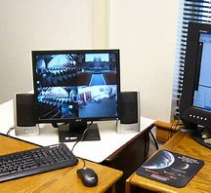
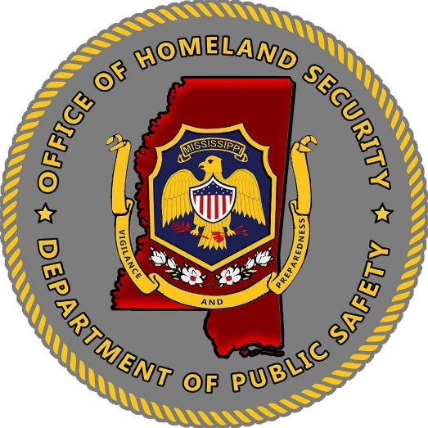

Mississippi Office of Homeland Security
2022 Homeland Security
Non-Profit Grant Program
Funding Guidance
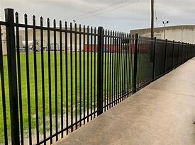

Schedule for FY22 Homeland
Security Non-Profit Security Grant Program
Key Announcements and Dates:

Key Announcements | Key Dates
Memo Re: Release of FY22 Non-Profit Grant Investment Justification | February 15, 2022
FY22 Grant Application Release | March 1, 2022
Grant Writing Sessions | March 9, 2022  March 11, 2022
Application Deadline | April 1, 2022, by 5:00 p.m.
Application Review Period | April 2022
Conditional Award Notification (Purchase/Authorize of spending is unallowable, until executed Agreement is Received from MOHS) | Summer 2022 (Tentative)
Grant Orientation | July 13, 2022 (Tentative)  July 15, 2022 (Tentative)
Grant Awards Released | September 1, 2022 (Tentative)
Grant Packets Due and to be Returned to MOHS | September 15, 2022 (Tentative)
Grant Performance Period | October 1, 2022-September 31, 2023
Grant Closeout Deadline | November 1, 2023

Application packets will be available at the Mississippi Office of Homeland Security website https://www.homelandsecurity.ms.gov/
Grant applications received after the due date will not be accepted for the allocation of funds, but may be considered, if funds become available within one (1) year.

Federal Award Overview:
Department of Homeland Security
FY2022 Homeland Security Non-Profit Security Grant Program
Assistance Listing Number (Formerly CFDA) 97.008
Federal Grant Period: 9/1/2022-8/31/2025
https://www.fema.gov/grants/nonprofit-security-grant-program

Grant guidance for the 2022 Homeland Security Non-Profit Security Grant Program (NSGP) is forthcoming from the U.S. Department of Homeland Security (DHS)/Federal Emergency Management Agency (FEMA). Grant requirements may change in the official grant funding Notice of Funding Opportunity (NOFO). If grant requirements change, applicants will be notified, and application modifications may be requested to fit updated grant requirements.
Annually, the DHS/FEMA issues the Fiscal Year (FY) Homeland Security Non-Profit Security Grant Program, NOFO and the FEMA Preparedness Grants Manual. Subrecipients must follow the programmatic requirements in the NOFO, FEMA Preparedness Grants Manual, and the applicable provisions in the Uniform Administrative Requirement, Cost Principles and Audit Requirements for Federal Awards located in Title 2, Code Federal Regulations, (C.F.R.)., Part 200.

Program Objective
The objective of the FY2022 NSGP is to provide funding for physical security enhancements and other security-related activities for nonprofit organizations that are at high risk of a terrorist attack. The NSGP also seeks to integrate the preparedness activities of nonprofit organizations with broader state and local preparedness efforts.

Anticipated Program Priorities
Given the evolving threat landscape, it is incumbent upon DHS/FEMA to continuously evaluate the national risk profile and set priorities that help ensure appropriate allocation of scarce security dollars. In assessing the national risk profile for FY 2022, one area attracts the most concern:

- Enhancing the protection of soft targets/crowded places;

Likewise, there are several enduring security needs that crosscut the homeland security enterprise. The following are second-tier priorities that help recipients implement a comprehensive approach to securing communities:
1. Effective planning;
2. Training and awareness campaigns; and
3. Exercises.

The table below provides a breakdown of these priority areas for the FY 2022 NSGP, showing both the core capabilities enhanced and lifelines supported, as well as examples of eligible project types for each area. A detailed description of allowable investments for each project type is included in the FEMA Preparedness Grants Manual.

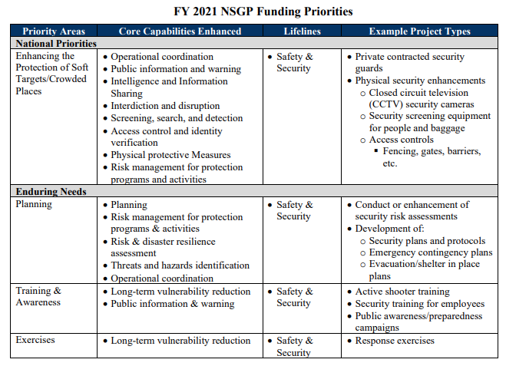
*FY22 Funding Priorities are anticipated to be the same as listed above for FY21.
National Preparedness Goal
“A secure and resilient nation with the capabilities required across the whole community to prevent, protect against, mitigate, respond to, and recover from the threats and hazards that pose the greatest risk.”

Mission Areas and Core Capabilities
Applicants are encouraged to consider investments and projects that support local, regional, and national efforts to support the five mission areas for Homeland Security:
- Prevention- Prevent, avoid, or stop an imminent, threatened, or actual act of terrorism.
- Protection- Protect our citizens, residents, visitors, and assets against the greatest threats and hazards in a manner that allows our interests, aspirations, and way of life to thrive.
- Mitigation- Reduce the loss of life and property by lessening the impact of future disasters.
- Response- Respond quickly to save lives, protect property and the environment, and meet basic human needs in the aftermath of a catastrophic incident.
- Recovery- Recover through a focus on the timely restoration, strengthening and revitalization of infrastructure, housing, and a sustainable economy, as well as the health, social, cultural, historic, and environmental fabric of communities affected by a catastrophic incident.

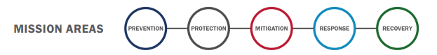
Applicants are encouraged to also consider projects that meet the FEMA Core Capabilities within the National Preparedness goal. There are thirty-two (32) core capabilities that fit within the five (5) mission areas that help build, sustain and agencies capabilities, along with close identified gaps.
FEMA Core Capabilities:
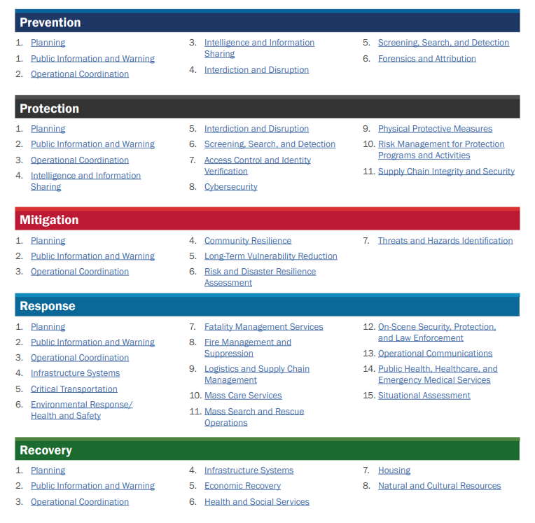
For more information on the core capabilities, please see the following link to FEMA Core Capability Development Sheets.
https://www.fema.gov/sites/default/files/documents/fema_ccds-all-sheets.pdf
Funding Eligibility
Eligible nonprofit organizations are those organizations that are:
- Described under section 501(c)(3) of the Internal Revenue Code of 1986 (IRC) and exempt from tax under section 501(a) of such code.

Note: The Internal Revenue Service (IRS) does not require certain organizations such as churches, mosques, and synagogues to apply for and receive a recognition of exemption under section 501(c)(3) of the IRC. Such organizations are automatically exempt if they meet the requirements of section 501(c)(3). These organizations are not required to provide recognition of exemption. For organizations that the IRS requires to apply for and receive a recognition of exemption under section 501(c)(3), the state may or may not require recognition of exemption, as long as the method chosen is applied consistently.

Refer to links below for additional information:
- https://www.irs.gov/charities-non-profits/charitable-organizations/exemptionrequirements-section-501-c-3-organizations
- https://www.irs.gov/publications/p557
- https://www.irs.gov/charities-and-nonprofits

- Able to demonstrate, through the application, that the organization is at high risk of a terrorist attack.

Below are entities that are not eligible to apply under the Nonprofit Security Grant Program. These entities are subject to change with release of the official 2022 Notice of Funding Opportunity from FEMA.
- Utility companies
- For-profit transportation companies, such as a company offering bus service
- For-profit hospitals
- Organizations active in politics, lobbying, and advocacy work
  - Volunteer fire departments
  - Community Service organizations (Kiwanis, Rotary, and Lions Clubs)
  - Homeowner Associations
- Labor, agricultural or horticultural organizations
  - Labor unions, county fairs, and flower societies are examples of these types of groups.
Nonprofit organizations must apply for FY2022 NSGP through the Mississippi Office of Homeland Security. Nonprofit organization may not apply directly to the Department of Homeland Security (DHS)/Federal Emergency Management Agency (FEMA).

What can I apply for?
If applicants have questions regarding the allowable or unallowable use of funding or need assistance in completing the application, please contact mohsgrants@dps.ms.gov. Applicants may also visit the FEMA website and review the Notice of Funding Opportunity to review all grant funding guidelines for this grant opportunity.

Please see the link below:

https://www.fema.gov/grants/preparedness/nonprofit-security/nonprofit-security-grant-program-notices-funding-opportunity

Funding Maximums (subject to change with the release of the official 2022 Notice of Funding Opportunity from FEMA):

Applicants with one site may apply for up to $150,000 for that site. Applicants with multiple sites may apply for up to $150,000 per site, for up to three sites, for a maximum of $450,000 per sub-applicant. If a sub-applicant applies for projects at multiple sites, regardless of whether the projects are similar in nature, it must include an assessment of the vulnerability and risk unique to each site. Failure to do so may be cause for rejection of the application.
Allowable Grant Items:
Please see the FY22 Homeland Security Notice of Funding Opportunity for additional information on allowable grant costs. The list below is not exhaustive, therefore, if applicants have any additional questions, please reach out to mohsgrants@dps.ms.gov.

Applicants may also visit the FEMA website and review the federal Notice of Funding Opportunity to review all grant funding guidelines for this grant opportunity. Please see the link below:

https://www.fema.gov/grants/preparedness/nonprofit-security/nonprofit-security-grant-program-notices-funding-opportunity

Eligible organizations may request NSGP funds to support the following activities. Each applicant must include its vulnerability/risk assessment on which the request(s) in the IJ is based.

Equipment: Allowable costs are focused on target hardening and physical security enhancements. Funding can be used for the acquisition and installation of security equipment on real property (including buildings and improvements) owned or leased by the nonprofit organization, specifically in prevention of and/or protection against the risk of a terrorist attack. This equipment is limited to select items in the following two sections of items on the Authorized Equipment List (AEL) and the following two specific items from other sections:
- Physical Security Enhancement Equipment (Section 14)
- Inspection and Screening Systems (Section 15)
- Handheld Radios (AEL 06CP-01-PORT – Radio Portable)
- Public Warning Systems (030E-03-MEGA – System, Public Address, Handheld or Mobile)

The two allowable prevention and protection categories and equipment standards for the NSGP are listed on Department of Homeland Security Authorized Equipment List. https://www.fema.gov/grants/guidance-tools/authorized-equipment-list

Unless otherwise stated, equipment must meet all mandatory statutory, regulatory, and DHS/FEMA-adopted standards to be eligible for purchase using these funds, including the Americans with Disabilities Act. In addition, recipients will be responsible for obtaining and maintaining all necessary certifications and licenses for the requested equipment.

Applicants should analyze the cost benefits of purchasing versus leasing equipment, especially high-cost items and those subject to rapid technical advances. Large equipment purchases must be identified and explained. For more information regarding property management standards for equipment, please reference 2 C.F.R. Part 200, including but not limited to 2 C.F.R. §§ 200.310, 200.313, and 200.316.

NSGP applicants can apply for the equipment and installation of the equipment listed below. Items not on the list below will not be funded.

AEL/SEL Number | Title | Description
14CI-00-COOP | System, Information Technology  Contingency Operations | Back-up computer hardware, operating systems, data storage, and application software necessary to provide a working environment for contingency operations. May be a purchased remote service or a dedicated alternate operating site.
14EX-00- BCAN | Receptacles, Trash, Blast-Resistant | Blast-resistant trash receptacles.
14EX-00-BSIR | Systems, Building, Blast/Shock/Impact Resistant | Systems to mitigate damage from blasts, shocks, or impacts, such as column and surface wraps, wall coverings, breakage/shatter resistant glass, window wraps, and deflection shields.
14SW-01-ALRM | Systems/Sensors, Alarm | Systems and standalone sensors designed to detect access violations or intrusions using sensors such as door/window switches, motion sensors, acoustic sensors, seismic, and thermal sensors. May also include temperature sensors for critical areas.
14SW-01-DOOR | Doors and Gates, Impact Resistant | Reinforced doors and gates with increased resistance to external impact for increased physical  security.
14SW-01- EXTM | System, Fire Extinguisher  Monitoring | System for monitoring the presence and pressure of fixed-location fire extinguishers to ensure that they are usable and are not stolen for possible misuse.
14SW-01-LITE | Lighting, Area, Fixed | Fixed high-intensity lighting systems for improved visibility in areas such as building perimeters and surveillance zones.
14SW-01-PACS  . | System, Physical Access Control | Locking devices and entry systems for control of  physical access to facilities
14SW-01-SIDP | Systems, Personnel  Identification | Systems for positive identification of personnel as a prerequisite for entering restricted areas or accessing information systems.
14SW-01-SIDV | Systems, Vehicle  Identification | Systems for identification of vehicles, ranging from decals to radio frequency identification (RFID) or other transponder devices
14SW-01- SNSR | Sensors/Alarms, System and Infrastructure Monitoring, Standalone | Standalone sensors/alarms for use on critical  systems or infrastructure items (security systems,  power supplies, etc.) to provide warning when these systems fail or are near failure.
14SW-01-VIDA | Systems, Video Assessment, Security | Camera-based security systems utilizing standard,  low light, or infrared technology.
14SW-01-WALL | Barriers: Fences; Jersey Walls | Obstacles designed to channel or halt pedestrian or vehicle-borne traffic in order to protect a physical asset or facility.
14SW-02-HSCN  . | Equipment, Hull Scanning | Devices or systems used to scan ship hulls for attached devices.
14SW-02-RADR | Systems, Radar | Scanning systems for detection of objects such as  vessels, personnel, and other objects.
14SW-02-SONR | Systems, Sonar | Devices or systems used to scan ship hulls for attached devices. Includes several different types of underwater sound wave imaging: Imaging Sonar: A high-frequency sonar that produces video-like imagery using a narrow field of view. The sonar system can be pole mounted over the side of a craft or hand-carried by a diver. Scanning Sonar: Consists of smaller sonar systems that can be mounted on tripods and lowered to the bottom of the waterway. Scanning sonar produces a panoramic view of the surrounding area and can cover up to 360 degrees. Side Scan Sonar: Placed inside of a shell and towed behind a vessel. Side scan sonar produces strip-like images from both sides of the device. 3-Dimensional Sonar: Produces 3-dimensional imagery of objects using an array receiver.
14SW-02- VBAR | Barriers, Vessel | Deployable, modular systems for restricting the  movement of vessels.
15IN-00-PLSN | System, Pulsed Neutron Activation, Non-Invasive | Screening system utilizing pulsed neutrons. Non-destructive detection of CWAs in sealed containers
15IN-00-RADR | Radar, Ground/Wall  Penetrating | Radar systems designed to penetrate walls or  ground to allow detection of hidden objects.
15IN-00-XRAY | System, Mobile Search & Inspection; X-Ray | Portable X-Ray systems for use in search and  screening operations.
15SC-00-PMON | Monitors, Portal | Systems to scan vehicles/cargo for radioactive  content. Various sizes for vehicles, packages (large and small) and pedestrians. Does not identify radionuclide. Note: For explosive detection portal, see Item 07ED-03-PORT. DIQCode: [D,Q]
15SC-00-PPSS | Systems, Personnel/Package Screening | Hand-held or fixed systems such as walk-through  magnetometers and conveyor-belt x-ray systems  used to screen personnel and packages for  hazardous materials/devices.
06CP-01-PORT | Radio, Portable | Individual/portable radio transceivers.
030E-03-MEGA | System, Public Address, Handheld or Mobile | Systems for mass audio notification, including  vehicle-mounted high powered speaker systems, or battery powered megaphone / public
**New For FY22**
- Radios/Communication Devices:
  - Radio/communication devices must be compatible with the MS Win Interoperable Communication System and approved P-25 radios.
  - Due to the large cost range of radio/communication device amounts, the MOHS will allow up to the following threshold amounts per radio.
  - MOHS will allow up to $2,000.00 per radio purchased for the MSWIN system.
  - Mississippi and the Mississippi Wireless Communication Commission have established vendor relations for the following vendors that carry and supply compatible radios and radio systems.

EF Johnson | Realm
Harris | Tait
Kenwood | Thales
Motorola

  - Exceptions may be requested by an agency for radios with a cost of $2,000.00 or more, with a detailed justification. Please include the following details in the justification:
    - Cost of each radio
    - Quantity requested
    - Where the Radios will be used and installed?
    - Why the agency needs additional upgrades/costs from the standard radio.

All justifications for radios requested with a cost of $2,000.00 or more will be reviewed by the Executive Committee and approved by the members therein.

Security Related Training: Nonprofit organizations may use NSGP funds for the following training-related costs:
- Employed or volunteer security staff to attend security-related training within the United States;
- Employed or volunteer staff to attend security-related training within the United States with the intent of training other employees or members/congregants upon completing the training (i.e., “train-the-trainer” type courses);
- Nonprofit organization’s employees, or members/congregants to receive on-site security training.

Allowable training-related costs under the NSGP are limited to attendance fees for training and related expenses, such as materials, supplies, and/or equipment. Overtime, backfill, and travel expenses are not allowable costs.

Allowable training topics are limited to the protection of critical infrastructure key resources, including physical and cybersecurity, target hardening, and terrorism awareness/employee preparedness such as Community Emergency Response Team (CERT) training, Active Shooter training, and emergency first aid training. Training conducted using NSGP funds must address a specific threat and/or vulnerability, as identified in the nonprofit organization’s IJ. Training should provide the opportunity to demonstrate and validate skills learned as well as to identify any gaps in these skills.

- Proposed attendance at training courses and all associated costs using NSGP funds must be included in the organization’s application.

Please pay close attention to the allowable security-related training topics in bold above. Applications for other training is unallowable and will not be considered.

Construction/Renovation: For construction costs to be allowed they must be specifically approved by FEMA, in writing, prior to the use of any NSGP program funds for construction or renovation.

NSGP funding may not be used for construction and renovation projects without prior written approval from DHS/FEMA. All recipients of NSGP funds must request and receive prior approval from DHS/FEMA before any NSGP funds are used for any construction or renovation. Additionally, recipients are required to submit a SF-424C Budget and budget detail citing the project costs. The total cost of any construction or renovation paid for using NSGP funds may not exceed the greater amount of $1,000,000.00 or 15% of the NSGP award. Recipients and subrecipients are also encouraged to have completed as many steps as possible for a successful EHP review in support of their proposal for funding (e.g., coordination with their State Historic Preservation Office to identify potential historic preservation issues and to discuss the potential for project effects, compliance with all State and EHP laws and requirements).

Projects for which the recipient believes an Environmental Assessment (EA) may be needed, as defined in DHS Instruction Manual 023-01-001-01, Revision 01, FEMA Directive 108-1, and FEMA Instruction 108-1-1, must also be identified to the FEMA HQ Program Analyst within six months of the award and completed EHP review materials must be submitted no later than 12 months before the end of the period of performance. EHP review packets should be sent to gpdehpinfo@fema.gov.
.
NSGP recipients using funds for construction projects must comply with the Davis-Bacon Act (codified as amended at 40 U.S.C. §§ 3141 et seq.). Grant recipients must ensure that their contractors or subcontractors for construction projects pay workers no less than the prevailing wages for laborers and mechanics employed on projects of a character similar to the contract work in the civil subdivision of the State in which the work is to be performed. Additional information regarding compliance with the Davis Bacon Act, including Department of Labor (DOL) wage determinations, is available from the following website: https://www.dol.gov/whd/govcontracts/dbra.htm.

Maintenance and Sustainment: Maintenance contracts, warranties, repair or replacement costs, upgrades, and user fees are only allowable in the following circumstances:
- The use of DHS/FEMA preparedness grant funds for maintenance contracts, warranties, repair or replacement costs, upgrades, and user fees are allowable, as described in FEMA Policy FP 205-402-125-1 under all active and future grant awards, unless otherwise noted. Except for maintenance plans or extended warranties purchased incidental to the original purchase of the equipment, the period covered by maintenance or warranty plan must not exceed the POP of the specific grant funds used to purchase the plan or warranty.

Environmental and Historical Preservation Compliance: All projects that may have potential impact to the environment will require a FEMA Environmental Historic Preservation form. For more information, please see FEMA Policy 108-023-1.
  - Ground disturbances, new construction, modification/renovation of buildings (include the addition of cameras, security doors, etc.) will require an EHP form to be submitted.
  - Renovation of and/or modification including installation of security and communication equipment to buildings or structures that are fifty (50) years old or older.
  - Installation of security features such as doors, cameras, security locks, etc., will also require an EHP submission for FEMA approval.
  - Security enhancements to improve perimeter security or any other construction or renovations that change or expand the footprint of the facility.
  - Physical security enhancements including, but not limited to:
    - Lighting
    - Fencing
    - Closed Circuit Televisions
    - Motion Detection
    - Barriers, doors, gates and related security enhancements.

Unallowable Grant Costs
The following items are considered unallowable by FEMA and/or the Mississippi Department of Homeland has deemed the items not permissible for funding. Applicants may also visit the FEMA website and review the Notice of Funding Opportunity to review all grant funding guidelines for this grant opportunity. Please see the link below,
https://www.fema.gov/media-collection/homeland-security-grant-notices-funding-opportunity

- Supplanting:
  - Grant funds will be used to supplement existing funds and will not replace (supplant) funds that have been appropriated for the same purpose. Applicants or recipients may be required to supply documentation certifying that a reduction in non-federal resources occurred for reasons other than the receipt or expected receipt of federal funds.

- FEMA Approval:
  - Grant funds may not be used for the purchase of equipment not approved by DHS/FEMA. Grant funds must comply with IB 426 and may not be used for the purchase of the following equipment: firearms; ammunition; grenade launchers; bayonets; or weaponized aircraft, vessels, or vehicles of any kind with weapons installed.

For additional information on allowable costs, see the FEMA Preparedness Grants Manual.
- Shipping costs
- Overtime, backfill, and/or travel expenses
- Weapons or weapons related training
- Organization costs, and operational overtime costs
- Hiring of public safety personnel
- General-use expenditures
- Initiatives that do not address the implementation of programs/initiatives to build prevention and protection-focused capabilities directed at identified facilities and/or the surrounding communities
- The development of risk/vulnerability assessment models
- Initiatives that fund risk or vulnerability security assessments or the development of the IJ
- Initiatives in which Federal agencies are the beneficiary or that enhance Federal property
- Initiatives which study technology development
- Proof-of-concept initiatives
- Initiatives that duplicate capabilities being provided by the Federal Government
- Organizational operating expenses
- Reimbursement of pre-award security expenses
- Cameras for license plate readers/license plate reader software
- Cameras for facial recognition software
- Knox Boxes

When Are Applications Due?
All HGSP applications and supporting documentation must be received by the Mississippi Office of Homeland Security offices by Friday, April 1, 2022, by 5:00 p.m. CST. Applications may be submitted before the deadline and encouraged. Applications received after this date and time may not be considered eligible for consideration.
To facilitate processing, please submit applications and supporting documentation via email to mohsgrants@dps.ms.gov.
What Do I Need to Do to Apply?
- Applicant(s) must be:
  - Described under section 501(c)(3) of the Internal Revenue Code of 1986 (IRC) and exempt from tax under section 501(a) of such code.

Note: The Internal Revenue Service (IRS) does not require certain organizations such as churches, mosques, and synagogues to apply for and receive a recognition of exemption under section 501(c)(3) of the IRC. Such organizations are automatically exempt if they meet the requirements of section 501(c)(3). These organizations are not required to provide recognition of exemption. For organizations that the IRS requires to apply for and receive a recognition of exemption under 501(c)(3), the state may or may not require recognition of exemption, as long as the method chosen is applied consistently.

  - Be able to demonstrate, through this application, that the organization is at high risk of a terrorist attack.
- Must be eligible for funding.
- The applicant must not be listed on the suspended and debarred list.
- The applicant must not be listed on the DPS Restricted Parties List.
- Applicants must have a current and active DUNS/Unique Entity Identification number.
- Applicant must read and comply with 2 CFR 200.317 to 2 CFR 200.327 regulations.
- Applicant must have written procurement standards per 2 CFR 200.318(a).
- Applicant must have written conflict of interest standards per 2 CFR 200.318(c).
- Applicant read and understands that certain telecommunications and video surveillance services or equipment are prohibited from being purchased using grant funds. See 2 CFR § 200.216 and 2 CFR § 200.471.
- Applicant must take necessary steps to assure that minority businesses, women's business enterprises, and labor surplus area firms are used, when possible, per 2 CFR 200.321.
- Applicant agrees that this federal funding does not supplant (replace) state, local, and agency monies in their organization's budget for the requested items in this application.

The following MUST items must be submitted, or the application will be considered incomplete.
- Complete Investment Justification/Application, submitted as an Excel document (all tabs must be completed)
- Agency Signatures
- Mission Statement on Letterhead
- Vulnerability/Risk Assessment
- Applicant Organizations that are not Ideology-based/Spiritual/Religious organizations must submit documentation from the IRS demonstrating that they are a 501(c)3.

What If I Have Questions about the Grant Application?
The Mississippi Office of Homeland Security is always available to answer any questions regarding the application packet and/or any grant questions

**NEW For FY22**
Grant Writing Sessions:
The MOHS will hold two (2) grant writing sessions to provide program updates, answer questions and assist in the development of the applications.
Grant Writing Sessions for the Homeland Security Grant Program

Wednesday, March 9, 2022  Virtual Training | Friday March 11, 2022  Virtual Training

What Happens After the Application Is Submitted?
Each application will go through a series of reviews for completeness, risk assessment, peer review, scoring and an executive planning and funding session. Please see below the stages of review for each application that is received.

Please Remember:
- Funding is limited.
- Funding is not guaranteed.

NSGP applications are to be submitted by nonprofit organizations to the MOHS. Applications will be reviewed through a multi-phase state and Federal review process for completeness, adherence to programmatic guidelines, feasibility, and how well the IJ (project description and justification) addresses the identified risk(s). The MOHS will make recommendations to DHS/FEMA based on their target allocation and according to the chart listed in the NSGP-S Process subsection.
MOHS Review: Application packages are submitted by the nonprofit organization to the MOHS based on the established criteria. The MOHS will review applications and recommend to DHS/FEMA which nonprofit organizations should be selected for funding.
1. The MOHS will review applications and recommend to DHS/FEMA which nonprofit organizations should be selected for funding. As part of the state review, the MOHS must: • Conduct an eligibility review. • Verify that the nonprofit is located outside an FY 2022 UASI-designated urban area.
2. Each member of the Nonprofit Security Working Group will review each application independently.
3. The Nonprofit Security Working Group Review and score all complete application packages (including vulnerability assessments and mission statement) using the NSGP Scoring Worksheet provided by DHS/FEMA.
4. A score will be calculated for each application.
5. The Working Group may choose to ask for additional documentation for review, as they see appropriate, to assist in the review and award process.
6. Applications will be scored, prioritized and recommendations for funding will be made to FEMA. The MOHS will
a. Submit the results of the state review along with complete applications from eligible applicants to DHS/FEMA.
b. Submit nonprofit organization application details for all applications received but not recommended for funding (including incomplete applications and ineligible applicants) to DHS/FEMA.
7. The MOHS will base its recommendations on the MOHS’s subject-matter expertise and discretion with consideration to the following factors:
- Need: The relative need for the nonprofit organization compared to the other applicants; and
- Impact: The feasibility of the proposed project and how effectively the proposed project addresses the identified need.

Federal (FEMA) Review: The IJs submitted by MOHS will be reviewed by DHS/FEMA HQ Program Analysts. Federal staff will verify that the nonprofit organization is located outside of an FY 2022 UASI-designated urban area. Federal reviewers will score each IJ using the NSGP Investment Justification Scoring Worksheet.
Final Score (NSGP-S): To calculate an application’s final score, the sum of the applicant’s SAA score and the Federal reviewer’s score will be multiplied:
- By a factor of three for nonprofit groups that are at a high risk of terrorist attacks due to their ideology, beliefs, or mission;
- By a factor of two for medical and educational institutions; and
- By a factor of one for all other nonprofit organizations.

Applicants will be selected from highest to lowest scored within their respective state/territory until the available state target allocation has been exhausted. In the event of a tie during the funding determination process, priority will be given to nonprofit organizations that have not received prior year funding, then those prioritized highest by the MOHS. Should additional NSGP-S funding remain unobligated after reviewing all state submissions, FEMA will use the final scores, in part, to determine how the remaining balance of funds will be allocated. Submissions will be selected for funding until the remaining balance of funds is exhausted.
DHS/FEMA will use the results to make funding recommendations to the Secretary of Homeland Security. All final funding determinations will be made by the Secretary of Homeland Security, who retains the discretion to consider other factors and information in addition to DHS/FEMA’s funding recommendations.
Notice of Award: All applicants will receive a notice of award or notice of non-approval.
Grant Award: If agency is awarded a grant, the applicant will become a sub-recipient. A grant award packet will be sent to the sub-recipient for the review and the attainment of signatures from all authorized officials. The grant award packet will include an Award Letter and Grant Agreement, along will all required grant documents.
Per FEMA requirements, the MOHS must meet the following four requirements.

- The SAA must make a firm commitment to passing through the grant funds to the sub-recipients.
- The SAA’s a commitment must be unconditional (i.e., no contingencies for the availability of funds).
- There must be documentary evidence (i.e., award document, terms, and conditions) of the commitment; and
- The award terms must be communicated to the sub-recipient.

Once the agency receives the grant award packet, the grant will be awarded and activated. Grant activities, procurement of equipment, etc., may begin at the receipt of the award packet.
Grant Orientation: At the receipt of the award packet, the agency will receive notice of an upcoming Grant Orientation meeting. The Grant Orientation will provide updates of the grant, award packet information, grant forms, information on required reporting and closeout. Grant Orientation is mandatory.
*New for FY22: Many of the forms and required documentation will be revised and updated for FY22, please include attendance at Orientation, the assigned Sub-Recipient Grant Administrator (SGA) and the assigned financial officer that will be working with the agency on financial matters.
Submission of Grant Award/Reimbursement: Grant award packets will be required to be submitted back to the MOHS email address of: MOHSgrants@dps,ms.gov, by a deadline date.
*New for FY22: Although grants awards are activated at the time of receipt of the award package, reimbursements will not be made to an agency until all award packets have been submitted and processed by MOHS grants staff. This may include the submission and approvals to FEMA for MOU’s, special equipment requests/approvals and Environmental Historic Preservations forms.

Completing the Grant Application
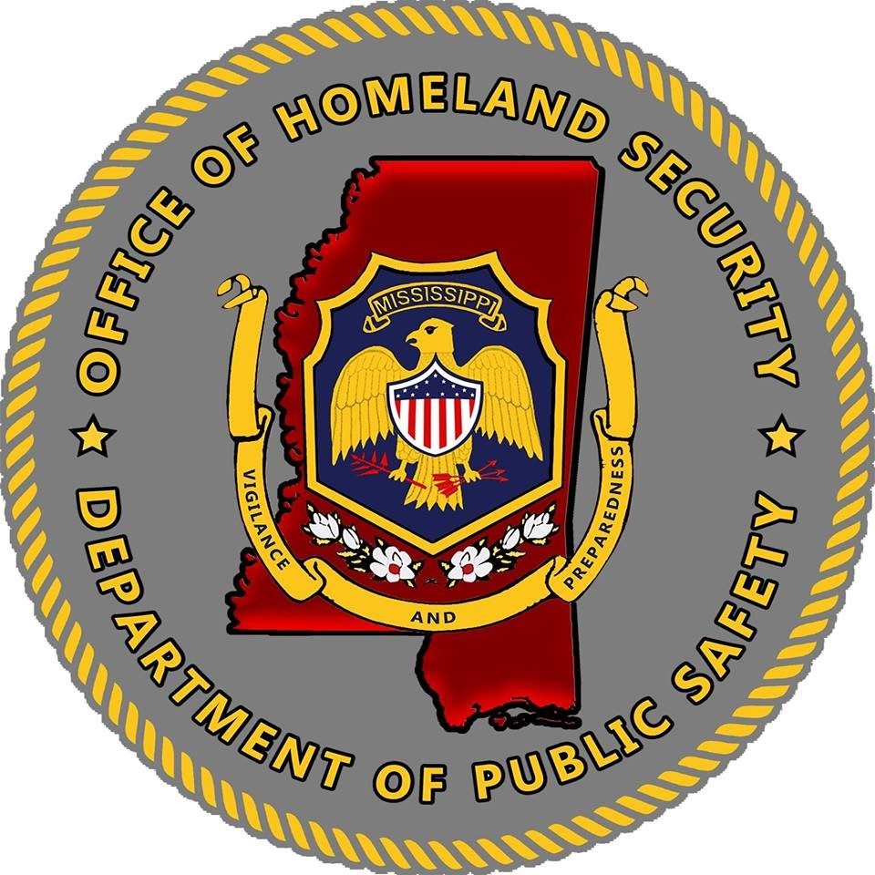

- Nonprofit Organization Applicant Information
Applicant Details:
- Legal Name of the Organization
- Physical Address of the Facility (One Justification per Facility; include city, state and zip code)
- County
- Year the Original Facility was Constructed
- Organization Type (Short Description of organizations ideology, beliefs and mission)
- Membership and community served
- 501©(3) Tax-Exempt Designation
- Dun and Bradstreet Number/Unique Entity ID# (Applications can only be submitted with a current and valid number, pending numbers will not be accepted)
- Urban Area Security Initiative-Designated Urban Area (If Applicable)
- NSGP Federal Funding Request
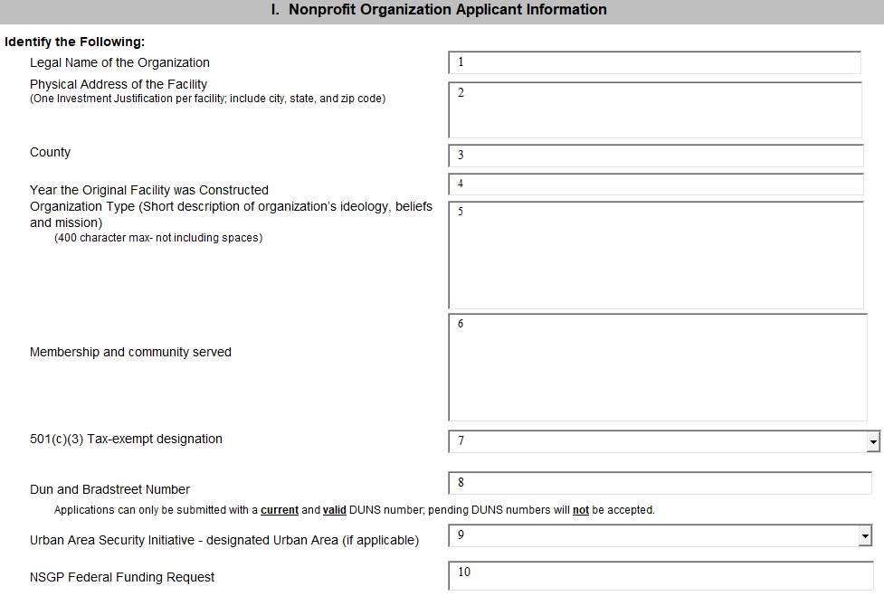
- NSGP Total Project Cost
- Any Current Contract with DHS (Yes or No)
- Investment Phase (New or Ongoing)

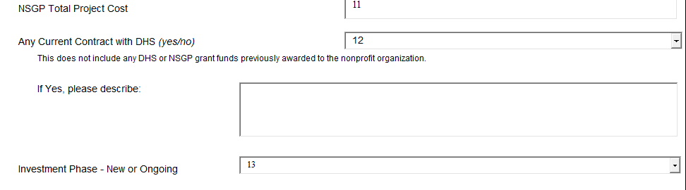
- Background
Describe the nonprofit organization including: (500 characters max per text box-including spaces)
- Describe the symbolic value of the site as a highly recognized national or historic institution or significant institution withing the community that renders the site as a possible target for terrorism.

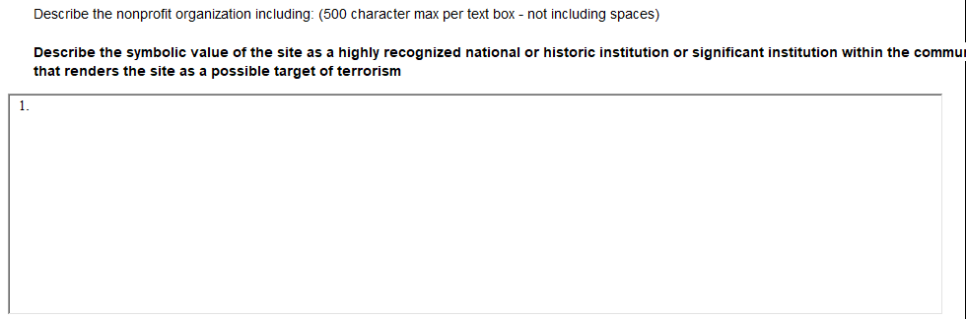

- Describe any previous or existing role in responding to or recovering from terrorist attacks.

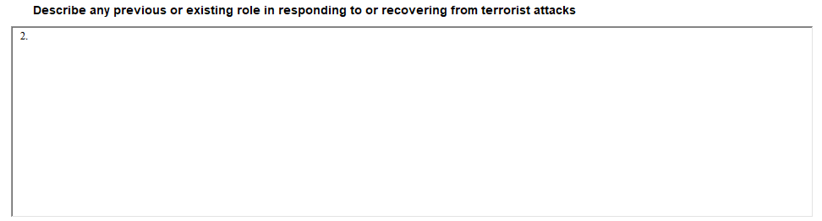

- Risk
DHS defines risk as the product of three principal variables: Thread, Vulnerability, and Consequences. In the space below, describe specific findings from previously conducted risk assessments, including A) Threats, B) Vulnerabilities, and (C) Potential Consequences of an attack.

- Threat: In considering threat, the applicant should discuss the identification and substantiation of specific threats or attacks against the nonprofit organization or closely related organization by a terrorist organization, network or cell. The applicant should also discuss findings from a risk assessment, police findings, and/or insurance claims specific to the location being applied for including dates and specific threats.

- Vulnerabilities: In considering vulnerabilities, the applicant should discuss the organizations susceptibility to destruction, incapacitation, or exploitation by a terrorist attack.

- Potential Consequences: In considering potential consequences, the applicant should discuss potential negative effects on the organization’s assets, system, and/or network if damaged, destroyed, or disrupted by a terrorist attack.
- Target Hardening
- In this section, describe the proposed target hardening activity that addresses the identified threat or vulnerability and the associated cost with each activity or investment. Allowable costs are focused on target hardening activities as well as planning related costs, exercise related costs, and security-related training courses and programs limited to the protection of critical infrastructure key resources, including physical and cyber security, target hardening, and terrorism awareness/employee preparedness. Funding can also be used for the acquisition and installation of security equipment on real property (including building and improvements) owned or leased by the nonprofit organization. (2,200 character max-not including spaces)

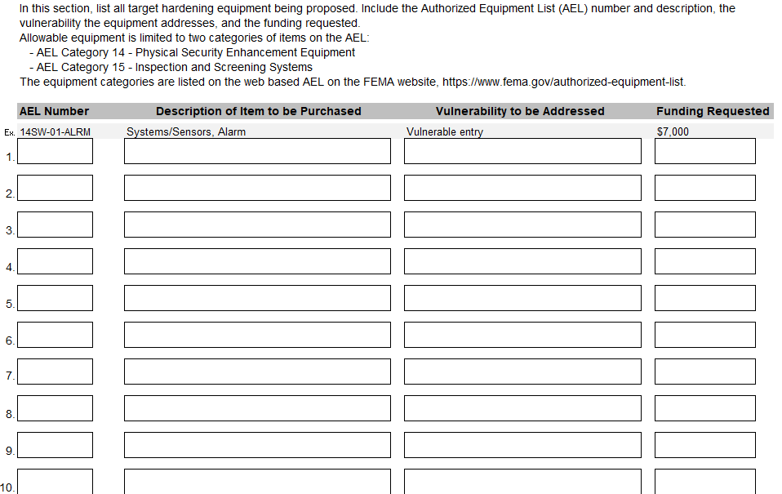
- Milestones
Provide description and associated key activities that lead to the milestone event over the NSGP period of performance. Start dates should reflect the start of the associated key activities and end dates should reflect when the milestone event will occur. Milestones should reflect considerations to the Environmental Planning and Historic Preservation reviews when applicable.
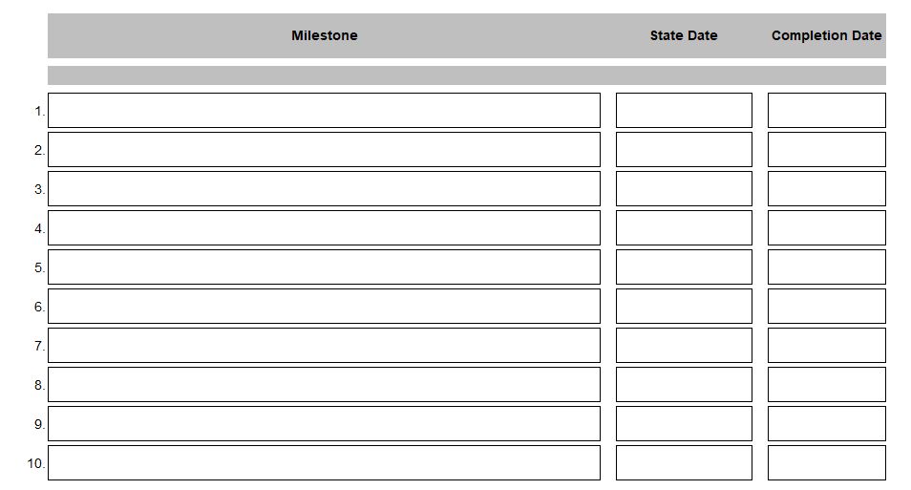

- Project Management
- Who will manage the Project: Include the name, phone number, and/or email address for the project manager(s).

- Describe the project management, including: (2,200 character max- not including spaces)
  - Description of any challenges to the effective implementation of this project.
  - Coordination of the project with the State and the local homeland security partners.

- Impact:
What measurable outputs and outcomes will indicate that this investment is successful at the end of the period of performance. (2,200 character max-not including spaces)

Which specific National Preparedness Goal (the Goal) core capabilities does this investment work to achieve? Explain how this investment supports the building or sustaining of these Goal Core Capabilities. For more information on the Goal see: http://www.fema.gov/national-preparedness-goal

VIII. Funding History:
If the nonprofit organization has received NSGP funding in the past, provide the funding source, funding amount, funding year, and the investment type. If the nonprofit organization has not received NSGP funding in the past, select no and skip to the next section.
- NSGP Funding in the Past (Yes or No)
- Year(s) NSGP Funding Received: Please include the years that were federally funded.
- Funding Amount: Please include the amount that were federally funded.
- Investment Type: New or Ongoing Project.
- Additional Information: Please include any additional information to add to the project for consideration.

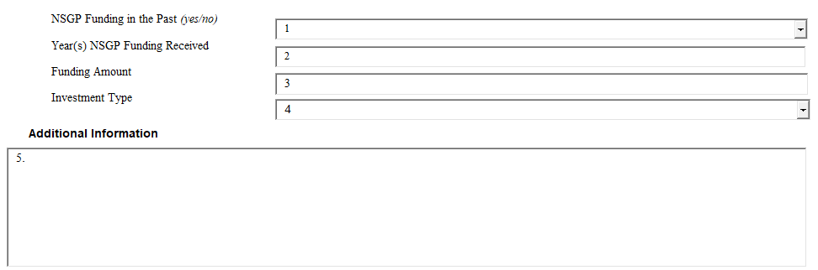
IX. Mission Statement
Please submit a Mission Statement of the Non-Profit Organization on Agency letterhead. Please include the mission of the organization, plans for the grant and the outcome of the grant.
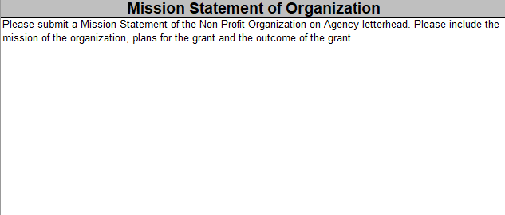

X. Applicant Contact Information
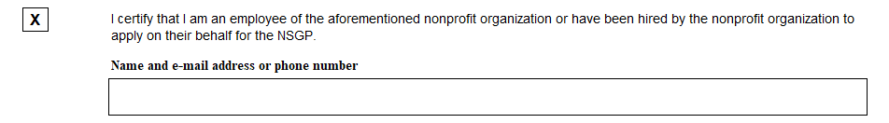
Additional Application Information
- Please mark the type of organization that is applying?

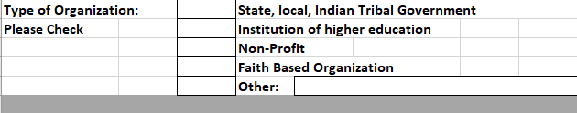
- Please mark Yes or No?

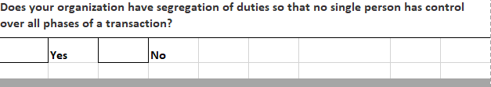
- Prior Experience:
Please fill out the below section to the best of applicant’s knowledge. Please mark applicants answer by a Yes or No Response. Complete all sections.
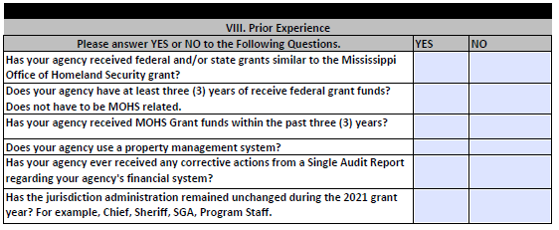

- Written Policies:
Please makes the written policies that the organization maintains.

