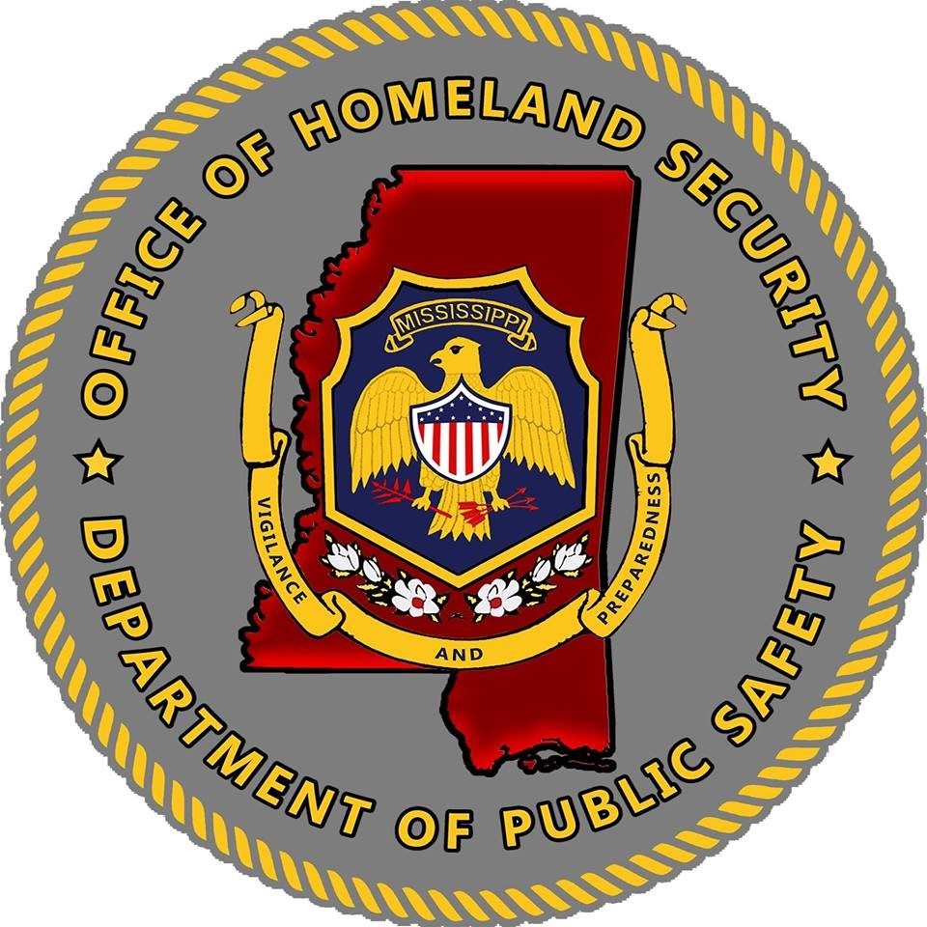

State of Mississippi
Mississippi Office of Homeland Security
State Advisory Committee
Charter

Table of Contents
Background ...…………………………………………………………………………………………………..…3
Purpose ……………………………………………………………………………………………………………3
Composition and Scope …………………………………………………………………………………………..3
Vision ……………………………………………………………………………………………………………..3
Authority ……………………………………………………………………………………………………….…3
SAC Responsibilities …………………………………………………………………………………………..…3
SAC Membership …………………………………………………………………………………………………4
SAC Appointment ………………………………………………………………………………………………...4
Conflicts of Interest ……………………………………………………………………………………………….4
SAC Meetings …………………………………………………………………………………………………….5
Governance ……………………………………………………………………………………………………….5
Charter Approval and Amendments ……………………………………………………………………………...6

SAC Appendix Documents
Appendix A: SAC Roster and Membership Agreement

Background:
The establishment of a Senior Advisory Committee (SAC) is required by the Federal Fiscal Year Homeland Security Grant Program Notice of Funding Opportunity (NOFO). Per the NOFO, state, administrative agencies, such as the Mississippi Office of Homeland Security (MOHS), must establish a SAC and provide a copy of the SAC charter, as part of the Application for the FY State Homeland Security Grant (SHSP) funds. This charter supersedes and replaces the SAC charter created by the MOHS in previous years.

Purpose:
The purpose of the SAC is to ensure that the SHSP funds are allocated in a manner that effectively supports and coordinates efforts regarding domestic security issues with the Federal Emergency Management Agency (FEMA) and the Department of Homeland Security (DHS). The SAC will work with the MOHS to support a whole community approach for emergency preparedness and management, while enhancing core capabilities aimed at achieving the National Preparedness goal.

National Preparedness Goal:
A secure and resilient nation with the capabilities required across the whole community to prevent, protect against, mitigate, respond to, and recover from threats and hazards that pose the greatest risk.

Composition and Scope:
The SAC must reflect the state’s unique risk profile and the interest of five mission areas, which are defined with in the National Preparedness Goal: (1) Prevention; (2) Protection; (3) Mitigation); (4) Response; and (5) Recovery.

Vision:
A comprehensive program for everyone in Mississippi to prevent, protect, mitigate, respond, and recover against terrorism attacks.

Authority:
The SAC is authorized and empowered by Executive Order No 916, while the Executive Order establishes the name of the Homeland Security Council, but for the Notice of Funding establishment, the Homeland Security Council is the same as the Senior Advisory Committee or SAC.

SAC Responsibilities:
The primary role of the SAC is to provide recommendations and advisory council to the SAA and MOHS. However, in other for the SAC to provide advisory recommendations, its members must be informed of certain documents and activities that are the responsibility of SAA and the MOHS.
- Threat Hazard Identification Risk Assessment (THIRA)
- Stakeholder Preparedness Review (SPR)
- HSGP Funding Process and Award Processes
- Strategy and Policy
- Management and Implementation of Projects

The SAC responsibilities are as follows:
- Responsible for advising and assisting the Governor with respect to all aspects of homeland security.
- Recognize the need to ensure that the focus of the SAC is first and foremost on the prevention of terrorist attacks against the homeland.
- Integrating preparedness activities across disciplines, the private sector, non-profit organizations, faith-based and community organizations, and all levels of government, including local, state, tribal, and territorial, with the goal of maximizing coordination and reducing duplication of effort.
- Creating a cohesive planning network that builds and implements preparedness initiatives using DHS/FEMA resources, as well as other Federal, state, local, tribal, territorial, the private sector, and faith-based community resources.
- Management of all available preparedness funding sources to ensure their effective use and to minimize duplication of effort.
- Ensuring applications for SHSP funds align with the capability gaps identified in the State's THIRA/SPR process.
- Assist in preparation and revision of the State, regional, or local homeland security plan or the threat and hazard identification and risk assessment, and
- Assist in determining effective funding priorities for SHSP grants.

SAC Membership:
Per the NOFO, the SAC membership shall include at least one (1) representative from relevant stakeholder including:
- Individuals from the counties, cities, and towns within the State.
- Representatives that were involved in the production of the state's THIRA/SPR.
- State and Urban Area Chief Information Officers (CIOs) and Chief Information Security Officers
(CISOs).
- Statewide Interoperability Coordinator (SWIC) and Statewide Interoperability Governing Body
(SIGB) members.
- Citizen Corps Whole Community Councils.
- Local government officials.
- Emergency response providers, including representatives of the fire service, law enforcement, emergency medical services, and emergency managers.
- Public health officials and other appropriate medical practitioners.
- Hospitals.
- Individuals representing educational institutions, including elementary schools, community colleges, and other institutions of higher education.
- State and regional interoperable communications coordinators, as appropriate.
- State and major urban area fusion centers, as appropriate; and
- Nonprofit, faith-based, and other voluntary organizations such as the American Red Cross.

SAC Appointment:
Members serve on the SAC upon invitation from the Mississippi’s Office of Homeland Security Advisor or the State Authorized Authority (SAA). Before serving on the SAC. A prospective member should receive the consent and support of the organization(s) the member represents. By signature, members indicate their agreement with the SAC Charter’s content and with their representation on the SAC.

An alternate may be chosen to represent an entity listed above in the temporary absence of the member who represents the entity.

Conflicts of Interest:
The members of the SAC shall not participate in any decision or vote, or discussion relating to a decision or vote, if the voting member has knowledge that any of the following has a financial interest in the outcome of the matter: The SAC member; a member of his or her immediate family; a business organization in which the SAC member is serving as an officer, member, director, trustee, partner, or employee; or a person or organization with whom the SAC member is negotiating or has an arrangement concerning prospective employment. If a conflict is identified, the SAC member shall recuse himself/herself from the discussion and the decision or vote.

Confidentiality:
The members of the SAC shall not divulge, benefit from, or attempt to benefit from confidential information that they receive, because of their membership on the SAC.

SAC Meetings:
Frequency:
The SAC will meet twice at year, but may call additional meetings as needed, with the following general goals for each meeting:

Spring/Summer:
- Discuss funding priorities; update and approve Charter for current FFY; ensure other application requirements are met and ready for filing when new NOFO is released.
- Applications are due; SAC and IDHS will review and score applications; make recommendations for which applications should be considered during executive session.
- Review SAC scores, IDHS scores and recommendations, and vote on awards; hold executive session for sensitive projects.

Fall/Winter:
- Assist with THIRA/SPR; conduct after action review; considerations for next year; discuss membership reappointment and new appointments.

Notice of Meeting:
Notice will be provided by email a minimum of two (2) weeks prior to the meeting date by the SAC chair or the SAA.

Location of Meeting:
The meetings will generally take place at a Department of Public Safety Office in Jackson, MS. However, some meetings may be held offsite. The meeting location and time will be placed in the notice of the meeting.

Remote Attendance:
Full membership of the SAC should be a priority but may be held remotely by audio or video conference at the discretion of the Chair or SAA.

Meeting Memoranda: A memoranda shall be kept as the meeting progresses containing the date, time, and location; a list noting which members are present and which are absent; the general substance of all matters proposed, discussed, or decided; a record of all votes taken; and any other information required.

Governance:
The SAC will comply with the Mississippi Ethics Commission compliance for the Open Meetings Act (MS Code 25-41 1-17). All SAC membership meetings are open to the public and announcements of meeting times, dates, locations, and meeting minutes will be maintained by the Chair or the SAA.
- Decisions are advisory only and made by a majority vote of SAC Members present at the meeting.
- No quorum is required for the SAC to conduct the meeting and/or any business of the meeting. A simple majority of the membership votes will be considered for a passing business plan.
- An Executive Committee may meet in the event of confidential or sensitive information is provided and should not be available to a public body.

Charter Approval/Amendments:
The charter should be reviewed annually to reflect the changes of the NOFO, federal guidance and the direction of the SAC, MOHS, and SAA. All amendments to the Charter must be provided to the SAA during the Fall/Winter meeting to be reviewed and added into the charter.

A vote will be taken at the Spring/Summer meeting to accept the Charter and/or approve amendments to the Charter. A revision date will be added to the Charter.

