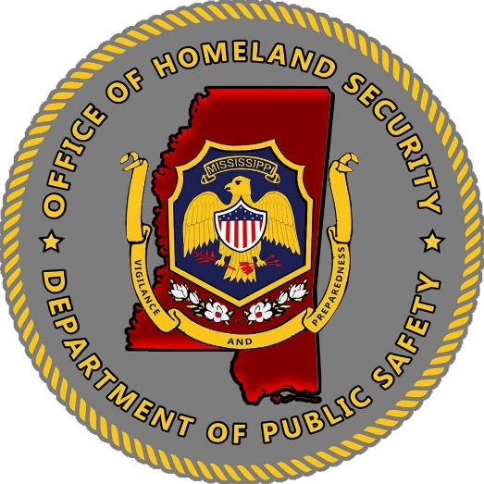
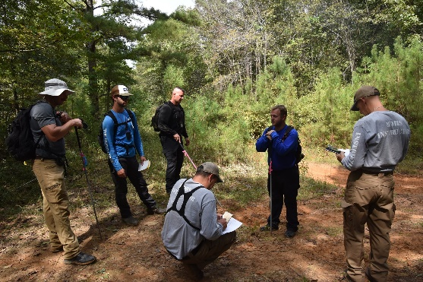
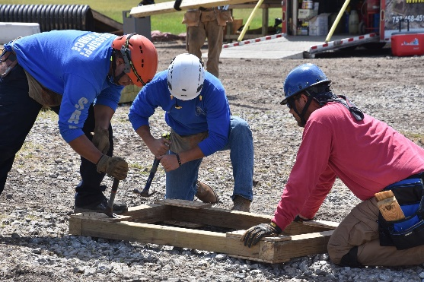

Mississippi Office of Homeland Security
2022 Homeland Security Grant Program
Community Preparedness
Funding Guidance
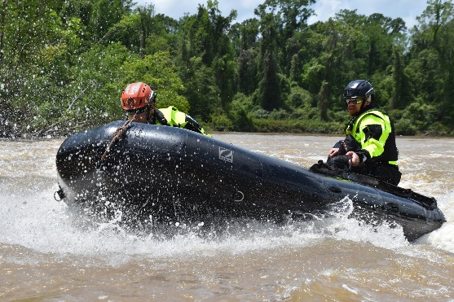
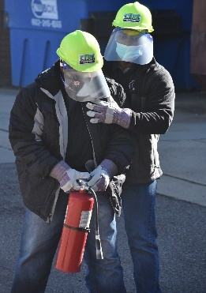
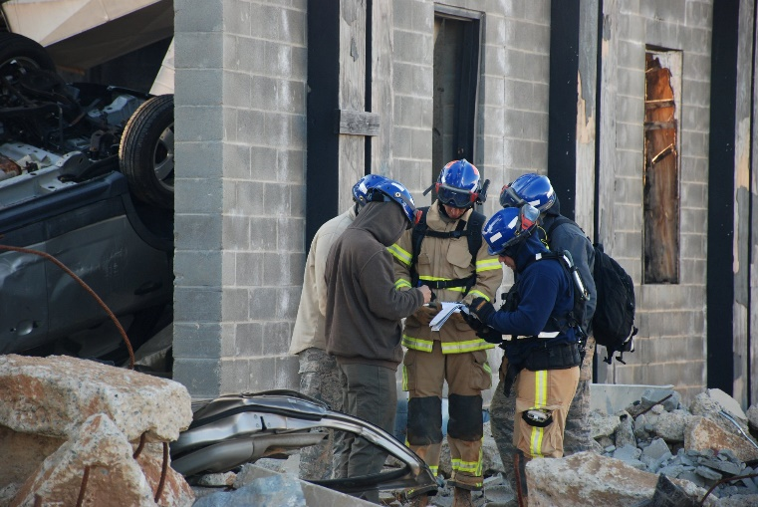

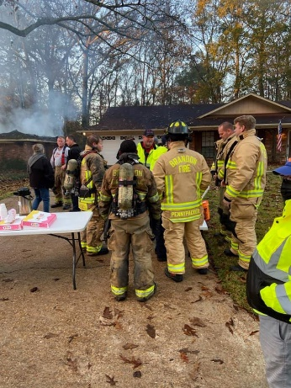

Schedule for FY22 Homeland Security Grant Program
Community Preparedness
Key Announcements and Dates:

Key Announcements | Key Dates
Memo Re: Release of FY22 Grant Application | September 16, 2022
FY22 Grant Application Release | September 30, 2022
Grant Writing Sessions  (Zoom Call) | October 7, 2022
Application Deadline | October 17, 2022, by 5:00 p.m.
Application Review Period | October 19-26 Initial Risk/Financial Assessment  November 1-Peer Review  November 8-Executive Award Review
Award Announcement | November 10, 2022 (Tentative)
Grant Orientation | November 16, 2022
Grant Awards Released | November 16, 2022
Grant Packets Due and to be Returned to MOHS | December 15, 2022 (Tentative)
Grant Performance Period | December 1, 2022-August 31, 2023
Grant Closeout Deadline | November 1, 2023

Application packets will be available at the Mississippi Office of Homeland Security website https://www.homelandsecurity.ms.gov/ Grant applications received after the due date will not be accepted for the allocation of funds, but may be considered, if funds become available within one (1) year.

Federal Award Overview:
Department of Homeland Security
FY2022 Homeland Security Grant Program
Assistance Listing Number (Formerly CFDA) 97.067
Federal Grant Period: 9/1/2022-8/31/2025
https://www.fema.gov/grants/preparedness/homeland-security

Program Objective
The objective of the FY2022 Homeland Security Grant Program-Community Preparedness grants are to fund local efforts to prepare the communities to be safer, stronger, and better prepared to respond to the threats of terrorism, crime, public health issues, and disasters of all kinds.

Funding Eligibility
Only eligible applicants may apply for Homeland Security Grant Program-Community Preparedness grants. Eligible applicants include those defined in the Department of Homeland Security Act of 2002:
- Local Units of government: The term “local government means-
  - A county, municipality, city, town, township, local public authority, school district, special district, intrastate district, council of government (regardless of whether the council of governments is incorporated as a non-profit under State law), regional or interstate government entity, or agency or instrumentality of a local government.
  - An Indian tribe or authorized tribal organization; and
  - A Rural community, unincorporated town or village, or other public entity.

- Applicants must have an active Unique Entity Identification Number (UEI) to apply for federal funding.
- Grant application requests are not a guarantee for funding. Grants may be funded in whole or partially funded. All funding considerations will be based on need and how the project fulfills the needs of the MOHS priorities and programs.
- The total amount of funding is limited to the amount received by FEMA, national priorities, and the requirements of the grant.
- Prioritize funding requests to items that meet the needs of the grant and applicant’s department. Awards will be made to projects with the needs identified in the application.
- All funding requests must be reasonable and allowable.

What can I apply for?
If applicants have questions regarding the allowable or unallowable use of funding or need assistance in completing the application, please contact mohsgrants@dps.ms.gov. Applicants may also visit the FEMA website and review the Notice of Funding Opportunity to review all grant funding guidelines for this grant opportunity. Please see the link below:

https://www.fema.gov/media-collection/homeland-security-grant-notices-funding-opportunity

When Are Applications Due?
All HGSP applications and supporting documentation must be received by the Mississippi Office of Homeland Security offices by Monday, October 17, 2022, by 5:00 p.m. CST. Applications may be submitted before the deadline and encouraged. Applications received after this date and time may not be considered eligible for consideration.
To facilitate processing, please submit applications and supporting documentation via email to mohsgrants@dps.ms.gov.
What Do I Need to Do to Apply?
- Must be eligible for funding.
- The applicant must not be listed on the suspended and debarred list.
- The applicant must not be listed on the Denied Parties List.
- The applicant must be NIMS complaint with NIMS Courses (100, 200,700 and 800).
- Applicants must have a current and active UEI number.
- Applicant must read and comply with 2 CFR 200.318 to 2 CFR 200.327 regulations.
- Applicant must have written procurement standards per 2 CFR 200.318(a).
- Applicant must have written conflict of interest standards per 2 CFR 200.318(c).
- Applicant read and understands that certain telecommunications and video surveillance services or equipment are prohibited from being purchased using grant funds. See 2 CFR § 200.216 and 2 CFR § 200.471.
- Applicant must take necessary steps to assure that minority businesses, women's business enterprises, and labor surplus area firms are used, when possible, per 2 CFR 200.321.
- Applicant agrees that this federal funding does not supplant (replace) state, local, and agency monies in their organization's budget for the requested items in this application.

The following MUST items must be submitted, or the application will be considered incomplete.
- Complete Application
- Agency Signatures

What If I Have Questions about the Grant Application?
The Mississippi Office of Homeland Security is always available to answer any questions regarding the application packet and/or any grant questions
**NEW For FY22**
Grant Writing Sessions:
The MOHS will hold one (1) grant writing sessions to provide program updates, answer questions and assist in the development of the applications.
Grant Writing Sessions for the Homeland Security Grant Program

Friday, October 7, 2022

What Happens After the Application Is Submitted?
Each application will go through a series of reviews for completeness, risk assessment, peer review, scoring and an executive planning and funding session. Please see below the stages of review for each application that is received.

Please Remember:
- Funding is limited.
- Please prioritize projects and requests. Awards will be made on the need identified, how the need will assist the State in the MOHS mission and if funds are available.
- Projects may be funded in whole or partially funded.

All applicants will receive a notice of award or notice of non-approval. All non-approval applications will be kept on file for (1) one year if funds become available. If funding becomes available, then a MOHS staff member will contact the agency to discuss opportunities.
If awarded, the applicant will then become a sub-grantee and receive notice of an upcoming Grant Orientation meeting. The MOHS will provide updates of the grant, award packet information, grant forms, information on required reporting and closeout. A grant award packet will be sent to the sub-grantee for the review and the attainment of signatures from all authorized officials.
Once the completed grant award packet is submitted back to MOHS, then the MOHS will acquire the required signatures and provide back to the subgrantee and fully executed agreement, along with a notice of activation. Grant funds cannot be spent or requested until the subgrantee has received the activation notice.
Completing the Grant Application
- Agency Applicant Information
- Date: Date of Application Submitted
- Name of Agency: Full name of the Agency.
- Mailing Address: Full mailing address of the Agency
- Agency Contact Name: Name of the person that is responsible for filling out the application.
- Agency Contact Phone Number: Phone number that can best reach the agency contact.
- Agency Contact Email Address: Email Address that can best reach the agency contact.
- EUI Number: Twelve (12) Digit code set up in SAMS.gov. Check with finance clerk for this number.
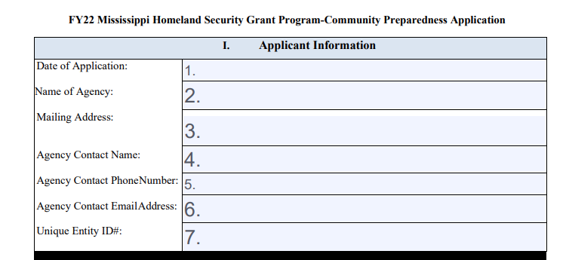
Cost Category:
- Commodities/Supplies: List the total amount requested for commodities/supplies.
- Contractual Services: List the total amount requested for contractual services
- Training/Travel: List the total amount request for travel. (Must be for training only)
- Total of Grant: Add all section (Sections 10-16) for a total grant amount requested.

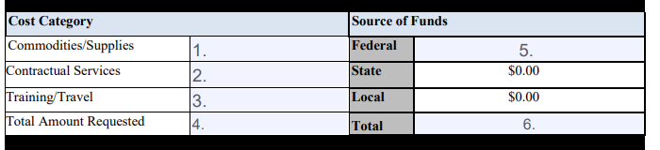

Source of Funds: All Requests will be 100% federally funded.
- Federal: List the full amount that will be federally funded.
- Total: List the full amount for the total grant amount requested.

- Community Preparedness Information
Please response with a Yes or No Response to the type of project that the Applicant is applying for:

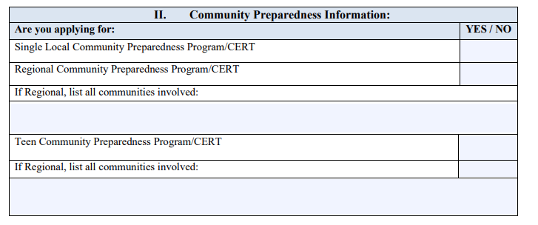

- Project Narrative
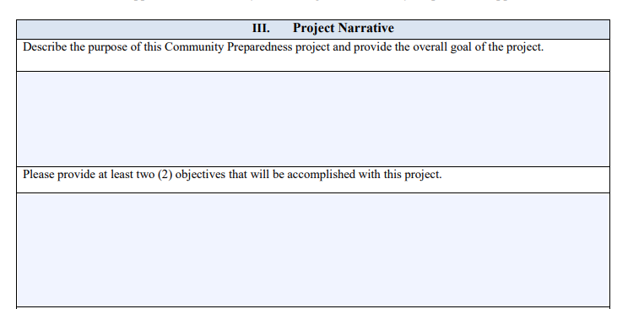
Please provide a detailed description to the following questions, please include as much detail as possible.
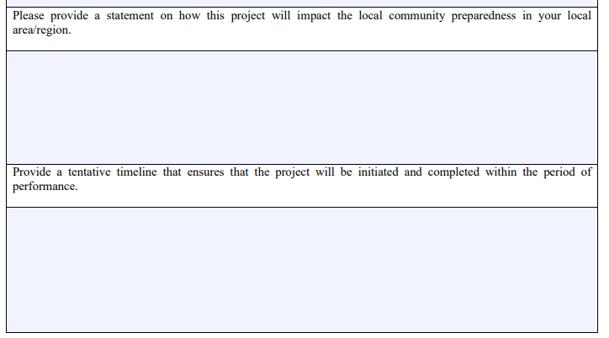

- Grant Budget:
- Commodities/Supplies:
Include a detailed assessment of commodity/supply expenses within the program area in which applicant are applying. Also, include a cost estimate for all additional grant expenses (gloves, traffic safety cones, flashlights, reflective safety vests, etc.). All expenses must be in accordance with current state and federal guidelines. Items are not identified as equipment.
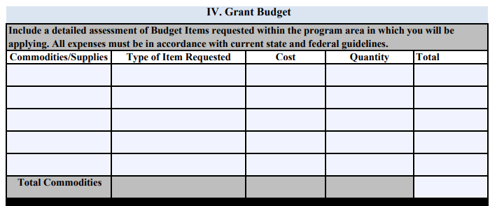

- Contractual Services:
Include a detailed assessment of contractual services within the program area in which applicant will be applying. Also, include a cost estimate for all contractual needs (rental, shipping costs, etc.). All expenses must be in accordance with current state and federal guidelines.

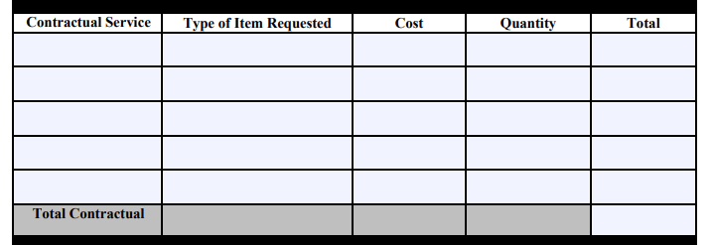

- Travel/Training:
Include a detailed assessment of travel/training needs within the program area in which applicant will be applying. Also, include a cost estimate for all travel needs (hotel, hotel taxes, per diem, mileage, parking, etc.). All expenses must be in accordance with current state and federal guidelines

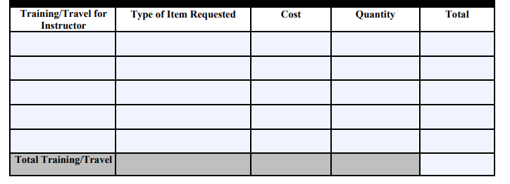

V. NIMS Compliance Form
Please read the following statement, if agency agrees to NIMS Compliance, please have the Authorized Signatory Official Sign.

The National Incident Management System (NIMS)guides all levels of government, nongovernmental organizations (NGO), and the private sector to work together to prevent, protect against, mitigate, respond to, and recover from incidents. NIMS provides stakeholders across the whole community with the shared vocabulary, systems, and processes to successfully deliver the capabilities described in the National Preparedness System. As recipients and subrecipients of federal preparedness (non-disaster) grant awards, jurisdictions and organizations must achieve, or be actively working to achieve, all the NIMS Implementation Objectives. The objectives can be found on the NIMS webpage at: https://training.fema.gov/nims/
Under Executive Order #932, Mississippi established NIMS as the standard for incident management within the State. The U.S. Department of Homeland Security/Federal Emergency Management Agency guidance provides that accepting grant funding is conditioned upon NIMS compliance. This jurisdiction attests that we continue to strive toward NIMS compliance, as provided under federal and State NIMS guidance.
This jurisdiction understands receiving and/or using U.S. Department of Homeland Security grant funds remains conditional upon NIMS compliance. Non-compliance of NIMS can result in funds being withheld or reallocated from our jurisdiction because of ineffective NIMS support and participation.
- Submission Compliance
Please read the following statements, if applicants agency agrees with the submission compliance, please have the person completing the Application fill out the following:
