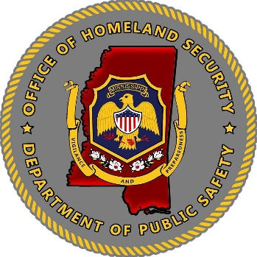
Mississippi Office of Homeland Security

Mississippi Office of Homeland Security Grant Program (HSGP)
FY22 HSGP-Community Preparedness
Notice of Funding Announcement
September 16, 2022
Purpose:
The objective of the FY2022 Homeland Security Grant Program-Community Preparedness grant is to fund local efforts to prepare the communities to be safer, stronger, and better prepared to respond to the threats of terrorism, crime, public health issues, and disasters of all kinds.

Solicitation:
Applicant must fill out the application form, completely. Projects meeting purpose, need and objectives for a Community Preparedness project will be considered for funding.

Application Release:
The Mississippi Office of Homeland Security (MOHS) will release the FY22 Homeland Security Grant program grant application on September 30, 2022. The application, along with the funding guidance document will be available on the MOHS website at: https://www.homelandsecurity.ms.gov/

Grant Writing:
The MOHS will also host one (1) grant writing workshops to answer questions regarding the grant and provide updates on grant funding, priority areas and information about the upcoming FY22 grant year. Dates for the grant writing sessions will be held on October 7, 2022.

Instructions and Deadlines:
All proposals must be submitted electronically to the MOHS email address at mohsgrants@dps.ms.gov by October 17, 2022, at 5:00 p.m. CDT. All fields are required to be completed and must include all required information and signatures for a completed application.

Applications submitted after the deadlines will not be considered for funding but may be considered if funding becomes available. Application submission does not guarantee funding. MOHS will review applications that align with the funding priorities of the agency.

Questions:
For questions related to the grant application, guidelines or need technical assistance, please contact the MOHS email address at mohsgrants@dps.ms.gov.

