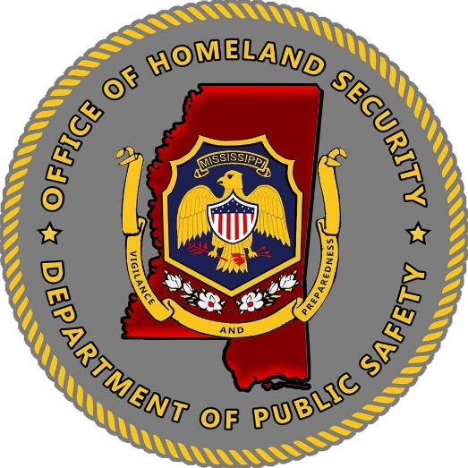
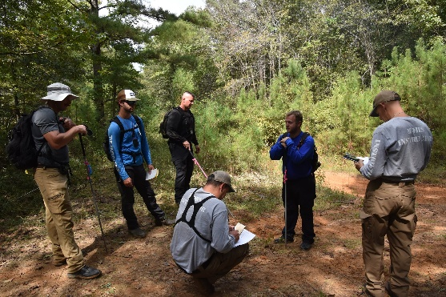
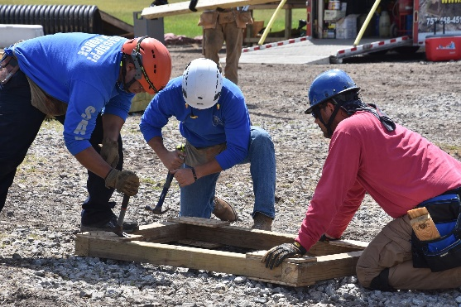

Mississippi Office of Homeland Security
2022 Homeland Security Grant Program
Funding Guidance
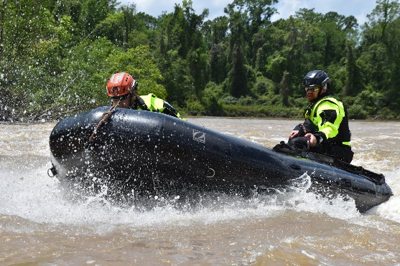
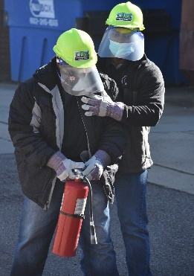
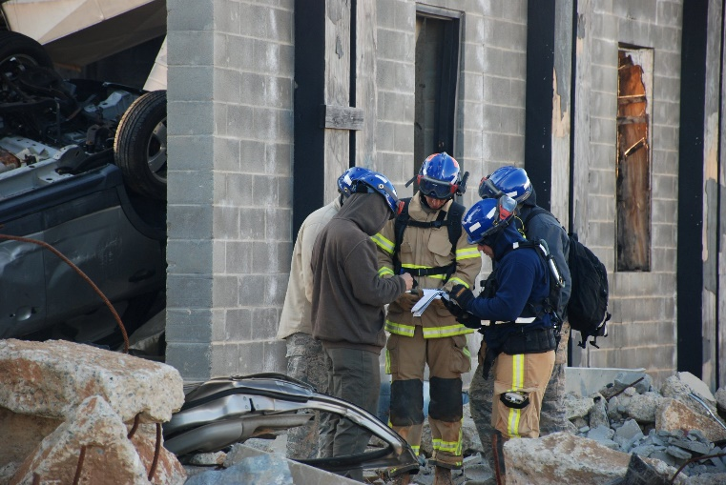

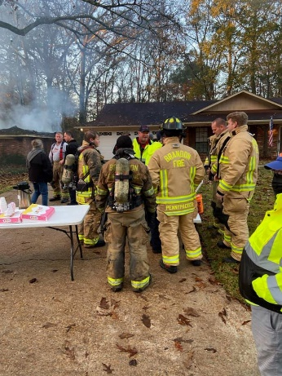

Schedule for FY22 Homeland Security Grant Program
Key Announcements and Dates:

Key Announcements | Key Dates
Memo Re: Release of FY22 Grant Application | February 1, 2022
FY22 Grant Application Release | February 15, 2022
Grant Writing Sessions | February 28, 2022  March 8, 2022
Application Deadline | April 1, 2022, by 5:00 p.m.
Application Review Period | April 2022-June 2022  Initial Risk/Financial Assessment Review (April)  Peer Review (May)  Executive Award Review (May/June)
Award Announcement | July 1, 2022 (Tentative)
Grant Orientation | July 12, 2022 (Tentative)  July 14, 2022 (Tentative)
Grant Awards Released | August 1, 2022 (Tentative)
Grant Packets Due and to be Returned to MOHS | September 15, 2022 (Tentative)
Grant Performance Period | September 1, 2022-August 31, 2023
Grant Closeout Deadline | November 1, 2023

Application packets will be available at the Mississippi Office of Homeland Security website https://www.homelandsecurity.ms.gov/
Grant applications received after the due date will not be accepted for the allocation of funds, but may be considered, if funds become available within one (1) year.

Federal Award Overview:
Department of Homeland Security
FY2022 Homeland Security Grant Program
Assistance Listing Number (Formerly CFDA) 97.067
Federal Grant Period: 9/1/2022-8/31/2025
https://www.fema.gov/grants/preparedness/homeland-security

Grant guidance for the 2022 Homeland Security Grant Program (HSGP) is forthcoming from the U.S. Department of Homeland Security (DHS)/Federal Emergency Management Agency (FEMA). Grant requirements may change in the official grant funding Notice of Funding Opportunity (NOFO). If grant requirements change, applicants will be notified, and application modifications may be requested to fit updated grant requirements.
Annually, the DHS/FEMA issues the Fiscal Year (FY) Homeland Security Grant Program, NOFO and the FEMA Preparedness Grants Manual. Sub-grantees must follow the programmatic requirements in the NOFO, FEMA Preparedness Grants Manual, and the applicable provisions in the Uniform Administrative Requirement, Cost Principles and Audit Requirements for Federal Awards located in Title 2, Code Federal Regulations, (C.F.R.)., Part 200.

Program Objective

The objective of the FY 2022 HSGP is to fund state, local, tribal, and territorial efforts to prevent terrorism and prepare the Nation for threats and hazards that pose the greatest risk to the security of the United States.

Program Purpose

The key focus and requirement of the HSGP is to prevent terrorism and other catastrophic events and to prepare the Nation for the threats and hazards that pose the greatest risk to security of the United States, including risks along the Nation’s borders.

The HSGP supports investments that improve the ability of jurisdictions nationwide to:
- Prevent a threatened or an actual act of terrorism.
- Protect citizens, residents, visitors, and assets against the threats that pose the greatest risk to the security of the United States.
- Mitigate the loss of life and property by lessening the impact of future catastrophic events.
- Respond quickly to save lives, protect property and the environment, and meet basic human needs in the aftermath of a catastrophic incident; and/or
- Recover through a focus on the timely restoration, strengthening, accessibility, and revitalization of infrastructure, housing, and a sustainable economy, as well as the health, social, cultural, historic, and environmental fabric of communities affected by a catastrophic incident, and do so in a manner that engages the whole community while ensuring the protection of civil rights.

National Priorities
The Mississippi Office of Homeland Security in its capacity of the SAA, work collaboratively with the DHS/FEMA in targeting specific projects with in the HSGP award to use Homeland Security grant funds most effectively.
For the FY22 grant cycle, the national priority areas will be prioritized for funding to align with the DHS/FEMA National Priority areas, set by the Department of Homeland Security. All applicants should prepare applications with the national priorities in mind.

National Priorities Areas, Core Capabilities, Lifelines and

Below please see an example list of each of the five national priorities with examples of possible projects for each.
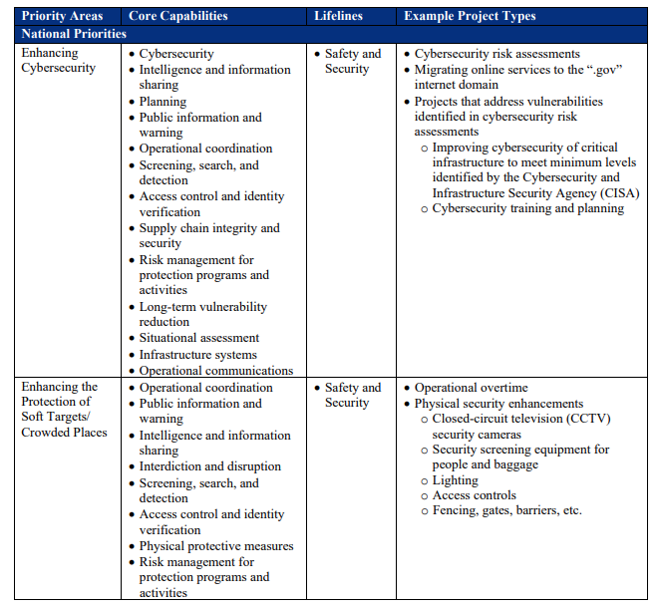
National Priorities Areas, Core Capabilities, Lifelines and Example Project Types

National Priorities Areas, Core Capabilities, Lifelines and Example Project Types
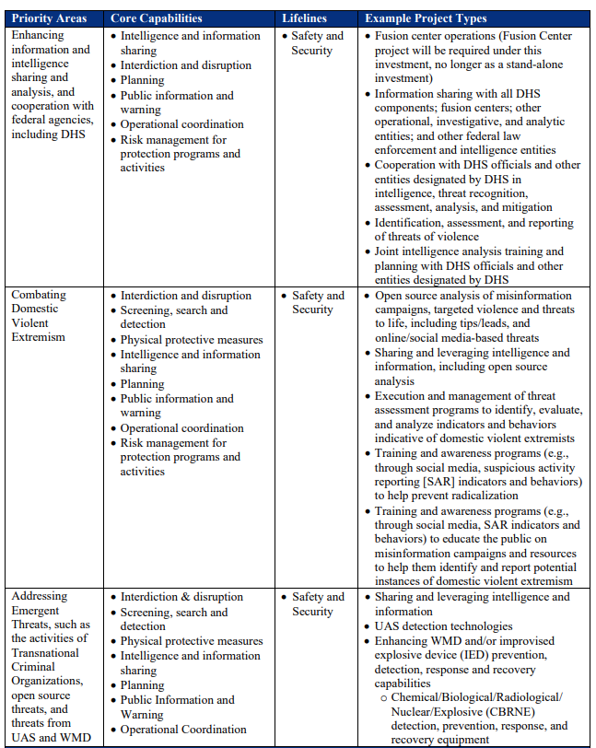
Anticipated 2022 Required Spending
Information for the 2022 National Priorities is forthcoming.
During FY2021, DHS/FEMA determined that the five (5) national priorities should be addressed by allocating a specific percentage of funds to each of the listed areas, for a total of thirty (30) percent of total funds. The MOHS will continue to invest in the specific areas of national priority, along with the required percentage and fund programs that focus on the national priorities.
Priorities are subject to change, but national priority programs and requirements are anticipated to remain in the FY22 grant cycle.

National Preparedness Goal
“A secure and resilient nation with the capabilities required across the whole community to prevent, protect against, mitigate, respond to, and recover from the threats and hazards that pose the greatest risk.”

Mission Areas and Core Capabilities
Applicants are encouraged to consider investments and projects that support local, regional, and national efforts to support the five mission areas for Homeland Security:
- Prevention- Prevent, avoid, or stop an imminent, threatened, or actual act of terrorism.
- Protection- Protect our citizens, residents, visitors, and assets against the greatest threats and hazards in a manner that allows our interests, aspirations, and way of life to thrive.
- Mitigation- Reduce the loss of life and property by lessening the impact of future disasters.
- Response- Respond quickly to save lives, protect property and the environment, and meet basic human needs in the aftermath of a catastrophic incident.
- Recovery- Recover through a focus on the timely restoration, strengthening and revitalization of infrastructure, housing, and a sustainable economy, as well as the health, social, cultural, historic, and environmental fabric of communities affected by a catastrophic incident.

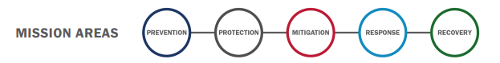
Applicants are encouraged to also consider projects that meet the FEMA Core Capabilities within the National Preparedness goal. There are thirty-two (32) core capabilities that fit within the five (5) mission areas that help build, sustain and agencies capabilities, along with close identified gaps.

FEMA Core Capabilities:
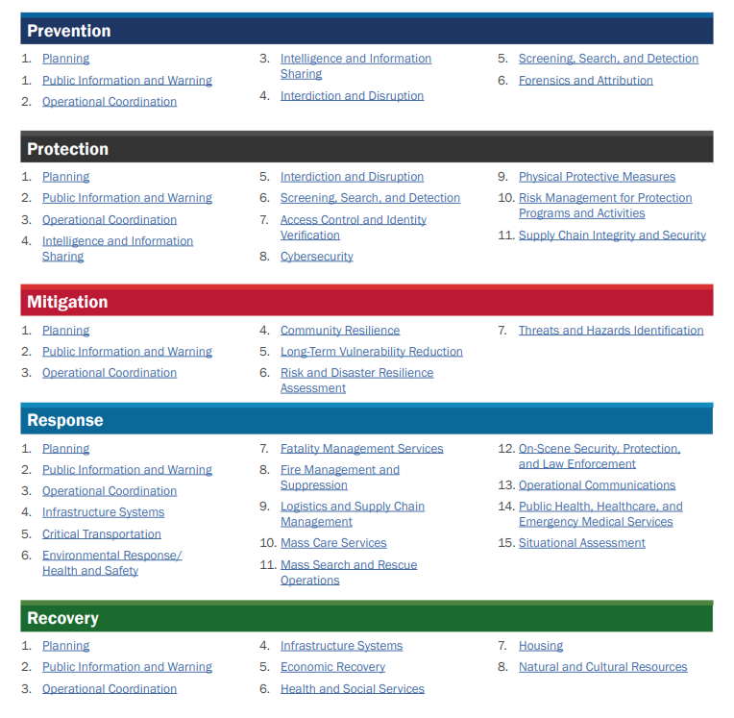
For more information on the core capabilities, please see the following link to FEMA Core Capability Development Sheets.
https://www.fema.gov/sites/default/files/documents/fema_ccds-all-sheets.pdf

Funding Eligibility
Only eligible applicants may apply for State Homeland Security Grant Program. Eligible applicants include those defined in the Department of Homeland Security Act of 2002:
- Local Units of government: The term “local government means-
  - A county, municipality, city, town, township, local public authority, school district, special district, intrastate district, council of government (regardless of whether the council of governments is incorporated as a non-profit under State law), regional or interstate government entity, or agency or instrumentality of a local government.
  - An Indian tribe or authorized tribal organization; and
  - A Rural community, unincorporated town or village, or other public entity.

- State Agencies: Under the SHSP, the State Administrative Agency (SAA) may retain no more than 20 percent of funding for expenditures made by the state on behalf of the local unit(s) of government. Funding outside of the 20 percent may occur only with the written consent of the local unit(s) of government and the approval of DHS/FEMA.

The Mississippi Office of Homeland maintains all MOU’s indicating written consent of the local unit(s) of government. All MOU’s must be submitted to FEMA, approval and the award will be at the discretion of FEMA’s approval, if funding will be allocated.

- Grant application requests are not a guarantee for funding. Grants may be funded in whole or partially funded. All funding considerations will be based on need and how the project fulfills the needs of the MOHS priorities and programs.

- The total amount of funding is limited to the amount received by FEMA, national priorities, and the requirements of the grant.

- Prioritize funding requests to items that meet the needs of the grant and applicant’s department. Awards will be made to projects with the needs identified in the application.

- All funding requests must be reasonable and allowable.

What can I apply for?
If applicants have questions regarding the allowable or unallowable use of funding or need assistance in completing the application, please contact mohsgrants@dps.ms.gov. Applicants may also visit the FEMA website and review the Notice of Funding Opportunity to review all grant funding guidelines for this grant opportunity. Please see the link below:

https://www.fema.gov/media-collection/homeland-security-grant-notices-funding-opportunity

Allowable Grant Items:
Please see the FY22 Homeland Security Notice of Funding Opportunity for additional information on allowable grant costs. The list below is not exhaustive, therefore, if applicants have any additional questions, please reach out to mohsgrants@dps.ms.gov.

Applicants may also visit the FEMA website and review the federal Notice of Funding Opportunity to review all grant funding guidelines for this grant opportunity. Please see the link below:
https://www.fema.gov/media-collection/homeland-security-grant-notices-funding-opportunity

Allowable Costs may include:
- Planning Costs
  - Develop and Implement programs and initiatives
  - Develop prevention activities
  - Develop and enhance plans and protocols
  - Develop and conduct assessments
  - Update structures and processes for emergency communication
  - Develop, review and revise continuity of operations plans
  - Develop, review and revise THIRA/SPR continuity of operations plans

- Organizational Activities
  - Develop structure and mechanisms for information sharing with the public and private sector
  - Operational support
  - Implementing models, programs, and workforce enhancement initiatives

- Program Activities
  - Training and Workshops

- Exercise Related Costs
  - Design, develop, conduct, and evaluate and exercise
  - Interoperable communication exercises

- Law Enforcement Terrorism Activities Costs
  - Coordination between fusion centers and other analytical and investigative efforts
  - Increase physical security through law enforcement
  - Integration and interoperability of systems and data

- Equipment
All requested equipment must be listed on the FEMA Authorized Equipment List (AEL) and must be listed under “FEMA related grant programs” for the Homeland Security Grant Program (HSGP). The applicant must indicate in the application the AEL number of the requested equipment, along with the description of items.
  - Personal protective equipment
  - Explosive device mitigation equipment
  - Search and rescue equipment
  - Interoperable communications
  - Physical security systems
  - Vehicle acquisition

**New For FY22**
- Radios/Communication Devices:
  - Radio/communication devices must be compatible with the MS Win Interoperable Communication System.
  - Due to the large cost range of radio/communication device amounts, the MOHS will allow up to the following threshold amounts per radio.
    - APX 900 $1,750.00
    - APX 6000 700/800 Radio $3,500.00

- Additional FEMA Approval: Some equipment requests may require additional approval from FEMA. MOHS may require additional information and detailed justifications for the request.

- Environmental and Historical Preservation Compliance: All projects that may have potential impact to the environment will require a FEMA Environmental Historic Preservation form. For more information, please see FEMA Policy 108-023-1.
  - Ground disturbances, new construction, modification/renovation of buildings (include the addition of cameras, security doors, etc.) will require an EHP form to be submitted.
  - Renovation of and/or modification including installation of security and communication equipment to buildings or structures that are fifty (50) years old or older.
  - Installation of security features such as doors, cameras, security locks, etc., will also require an EHP submission for FEMA approval.
  - Security enhancements to improve perimeter security or any other construction or renovations that change or expand the footprint of the facility.
  - Physical security enhancements including, but not limited to:
    - Lighting
    - Fencing
    - Closed Circuit Televisions
    - Motion Detection
    - Barriers, doors, gates and related security enhancements.

Unallowable Grant Costs
The following items are considered unallowable by FEMA and/or the Mississippi Department of Homeland has deemed the items not permissible for funding. Applicants may also visit the FEMA website and review the Notice of Funding Opportunity to review all grant funding guidelines for this grant opportunity. Please see the link below,
https://www.fema.gov/media-collection/homeland-security-grant-notices-funding-opportunity

- Supplanting:
  - Grant funds will be used to supplement existing funds and will not replace (supplant) funds that have been appropriated for the same purpose. Applicants or recipients may be required to supply documentation certifying that a reduction in non-federal resources occurred for reasons other than the receipt or expected receipt of federal funds.

- FEMA Approval:
  - Grant funds may not be used for the purchase of equipment not approved by DHS/FEMA. Grant funds must comply with IB 426 and may not be used for the purchase of the following equipment: firearms; ammunition; grenade launchers; bayonets; or weaponized aircraft, vessels, or vehicles of any kind with weapons installed.

- Weapons, Ammunition and Equipment:
  - Per FEMA policy, the purchase of weapons and weapons accessories, including ammunition, is not allowed with HSGP funds.
  - Small, unmanned Aircraft (SUAS) Drones.

  - Body worn cameras.

- Maintenance Contacts:
  - Maintenance contracts, warranties, repair or replacement costs, upgrades, and user fees are only allowable in the following circumstances:
    - The use of DHS/FEMA preparedness grant funds for maintenance contracts, warranties, repair or replacement costs, upgrades, and user fees are allowable, as described in FEMA Policy FP 205-402-125-1 under all active and future grant awards, unless otherwise noted. Except for maintenance plans or extended warranties purchased incidental to the original purchase of the equipment, the period covered by maintenance or warranty plan must not exceed the POP of the specific grant funds used to purchase the plan or warranty.

- Unauthorized exercise-related costs include:
  - Reimbursement for the maintenance or wear and tear costs of general use vehicles (e.g., construction vehicles), medical supplies, and emergency response apparatus (e.g., fire trucks, ambulances).

  - Equipment
    - Equipment/ supplies that are purchased for permanent installation and/or use, beyond the scope of the conclusion of the exercise (e.g., electronic messaging sign)

- In-Direct Costs

- Personnel, Overtime and Backfill costs:
  - Hiring of sworn public safety officers or supplant safety positions and responsibilities.
  - Salaries and personnel costs of planners, equipment managers, exercise coordinators and/or training coordinators.
  - Please note that overtime and backfill for training and exercise are only allowable in the following circumstances:
    - Training:
      - Overtime and backfill for emergency preparedness and response personnel attending DHS/FEMA-sponsored and approved training classes only.
      - Overtime and backfill expenses for part-time and volunteer emergency response personnel participating in DHS/FEMA training only.

  - Exercises:
    - Overtime and backfill costs, including expenses for part-time and volunteer emergency response personnel participating in DHS/FEMA exercises

- The following are common requests that are unallowable and/or unfunded:
  - Requests for equipment for routine/general use.
    - All SHSP equipment requested must assist recipients and subrecipients in achieving core capabilities related to preventing, preparing for, protecting against, or responding to acts of terrorism.
    - For more information refer to “Explain how applicants proposed project supports terrorism preparedness” the of this RFP.

  - Tactical law enforcement protective equipment for routine use or riot suppression. Items in this category are allowable only to supplement normal stores, in order to provide the surge capacity necessary for CBRNE terrorism response.

  - Vehicles
    - While certain vehicles are allowable, applications for vehicles will be reviewed on a case-by-case basis based on need, use, and justification.
    - General purpose vehicles (patrol cars, executive transportation, fire trucks and tactical/assault vehicles, etc.)
    - Reimbursement for the maintenance and/or wear and tear costs of general use vehicles, medical supplies, and emergency response apparatus.

When Are Applications Due?
All HGSP applications and supporting documentation must be received by the Mississippi Office of Homeland Security offices by Friday, April 1, 2022, by 5:00 p.m. CST. Applications may be submitted before the deadline and encouraged. Applications received after this date and time may not be considered eligible for consideration.
To facilitate processing, please submit applications and supporting documentation via email to mohsgrants@dps.ms.gov.
What Do I Need to Do to Apply?
- Must be eligible for funding.
- The applicant must not be listed on the suspended and debarred list.
- The applicant must not be listed on the Denied Parties List.
- The applicant must be NIMS complaint with NIMS Courses (100, 200,700 and 800).
- Applicants must have a current and active DUNS number.
- Applicant must read and comply with 2 CFR 200.318 to 2 CFR 200.327 regulations.
- Applicant must have written procurement standards per 2 CFR 200.318(a).
- Applicant must have written conflict of interest standards per 2 CFR 200.318(c).
- Applicant read and understands that certain telecommunications and video surveillance services or equipment are prohibited from being purchased using grant funds. See 2 CFR § 200.216 and 2 CFR § 200.471.
- Applicant must take necessary steps to assure that minority businesses, women's business enterprises, and labor surplus area firms are used, when possible, per 2 CFR 200.321.
- Applicant agrees that this federal funding does not supplant (replace) state, local, and agency monies in their organization's budget for the requested items in this application.

The following MUST items must be submitted, or the application will be considered incomplete.
- Complete Application
- Agency Signatures

What If I Have Questions about the Grant Application?
The Mississippi Office of Homeland Security is always available to answer any questions regarding the application packet and/or any grant questions

**NEW For FY22**
Grant Writing Sessions:
The MOHS will hold two (2) grant writing sessions to provide program updates, answer questions and assist in the development of the applications.
Grant Writing Sessions for the Homeland Security Grant Program

Tuesday, March 1, 2022 | Tuesday, March 8, 2021

What Happens After the Application Is Submitted?
Each application will go through a series of reviews for completeness, risk assessment, peer review, scoring and an executive planning and funding session. Please see below the stages of review for each application that is received.

Please Remember:
- Funding is limited.

- Please prioritize projects and requests. Awards will be made on the need identified, how the need will assist the State in the MOHS mission and if funds are available.

- Projects may be funded in whole or partially funded.

All applicants will receive a notice of award or notice of non-approval. All non-approval applications will be kept on file for (1) one year if funds become available. If funding becomes available, then a MOHS staff member will contact the agency to discuss opportunities.
If awarded, the applicant will then become a sub-grantee and receive notice of an upcoming Grant Orientation meeting. The MOHS will provide updates of the grant, award packet information, grant forms, information on required reporting and closeout. A grant award packet will be sent to the sub-grantee for the review and the attainment of signatures from all authorized officials.
Once the completed grant award packet is submitted back to MOHS, then the MOHS will acquire the required signatures and provide back to the subgrantee and fully executed agreement, along with a notice of activation. Grant funds can not be spent or requested until the subgrantee has received the activation notice.

Completing the Grant Application
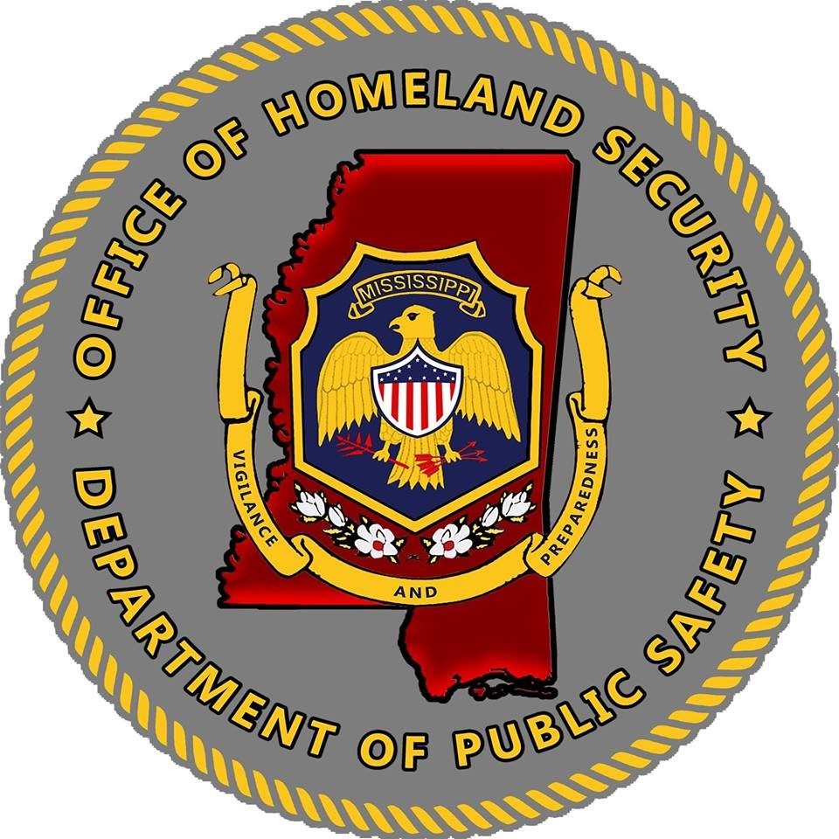

- Agency Applicant Information

Applicant Details:
- Date: Date of Application Submitted
- Name of Agency: Full name of the Agency.
- Mailing Address: Full mailing address of the Agency
- County of Agency: Name of the county where the Agency resides.
- Agency Contact Name: Name of the person that is responsible for filling out the application.
- Agency Contact Phone Number: Phone number that can best reach the agency contact.
- Agency Contact Email Address: Email Address that can best reach the agency contact.
- DUNS Number: Nine (9) Digit code set up in SAMS.gov. Check with finance clerk for this number.
- Congressional District: Congressional district where the agency resides.
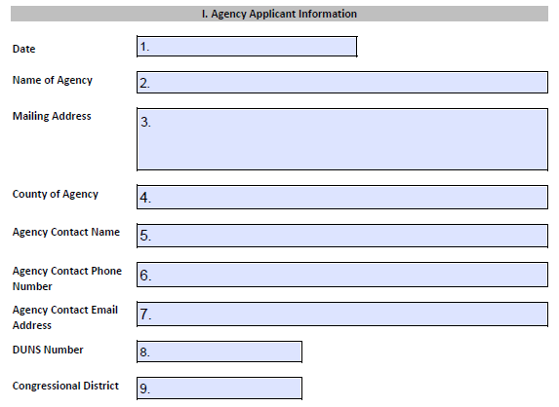

Cost Category:
- Personal Services-Salary: List the total amount requested for the personal services for salary. (Task Forces, Operation Stonegarden, Training and Citizen Corp Only)
- Personal Services-Fringe: List the total amount requested for the personal services for fringe benefits. (Task Forces, Operation Stonegarden, Training and Citizen Corp Only)
- Contractual Services: List the total amount requested for contractual services (Task Forces Only)
- Travel: List the total amount request for travel. (Must be for training only)
- Equipment: List the total amount of equipment requested.
- Commodities/Supplies: List the total amount requested for commodities/supplies.
- Other: List any expenses that does not fall within the above categories.
- Total of Grant: Add all section (Sections 10-16) for a total grant amount requested.

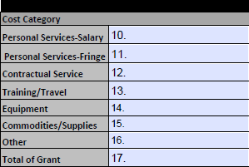
Source of Funds:
All Requests will be 100% federally funded.
- Federal: List the full amount that will be federally funded.
- Total: List the full amount for the total grant amount requested.

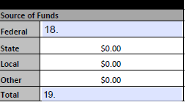

Approved Authorized Signature:

- Approved Authorized Signature. Signature from Mayor/Board of Supervisor/Commission/Board President, etc.

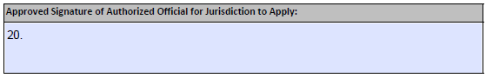

- Problem Identification
- Surrounding Counties: List all counties that surround the county that the agency is located
- Number of Square Miles: List Number of square miles where the agency is located. Ex. City of New York-15 miles or County of Yorktown-180 miles.
- Number of Population: List the number of the population where the agency is located.
- Number of Officers/Staff working in Agency: List the number of officers and/or staff that work in the agency.

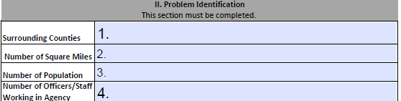

- Jurisdiction’s Top Three Threats
Describe applicants first top threat, second threat and three threats.
FEMA describes a "threat" as a natural, technological, or human caused occurrence, individual, entity or action that has or indicated potential to harm life, information, operations, the environment and/or property. Threats should be related the prevention of terrorist and other catastrophic events. These threats should be unique to applicants’ area targets, infrastructure, and population. Please describe in detail the top three threats to applicant area.

** Please note. Natural disasters can be considered and listed as one of applicants three threats but should not be the only threats to applicant agency or area.

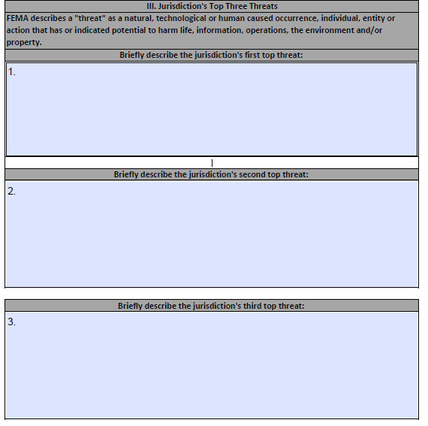

- Jurisdiction’s Top Three Hazards

- Describe applicants first top hazards, second hazards and third hazards.

FEMA describes a "Hazard" as something that is potential dangerous or harmful, often the root cause of an unwanted outcomes. These hazards should be unique to applicants’ area targets, infrastructure, and population. Please describe in detail the top three threats to applicants’ area.

** Please note. Natural disasters can be considered and listed as one of applicants three hazards but should not be the only hazards to applicant’s agency or area.

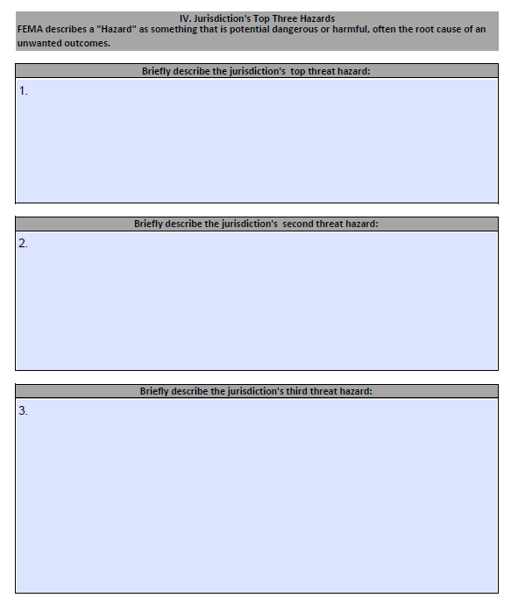
- Capability Gaps

- Provide a description of any capability gap(s) which inhibits the jurisdiction's ability to Prevent, Protect, Mitigate, Respond and/or Recovery. Explain how applicant determined the capability gaps (i.e., a response to a real-life event, an exercise, training event or threat assessment). Please address how utilization of existing state-wide assets (task forces, force protection units, bomb teams, etc.) may/may not mitigate the threats and hazards that have been identified.
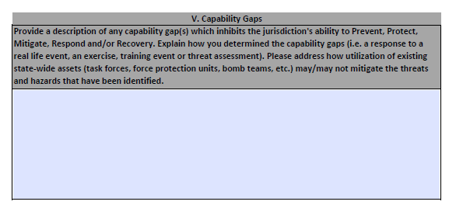
- National Priority, Mission Area and Core Capabilities

National Priority:

Sections 1-5: Please mark the National Priority that the Agency will support with the funds received.

- Cyber Security: Enhancing Cyber Security

- Information and Intelligence Sharing: Enhancing information and intelligence sharing and cooperation with federal agencies, including MOHS and Department of Homeland Security

- Emerging Threats: Addressing emergent threats in applicants’ area.

- Soft Targets/Crowded Places: Enhancing the protection of soft targets in crowded places.

- Domestic Violent Extremism: Addressing violent extremism in applicants’ area.

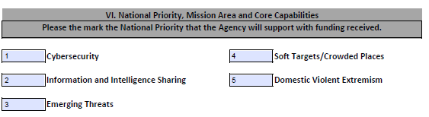

Please describe how the funding will be used to support the National Priority.
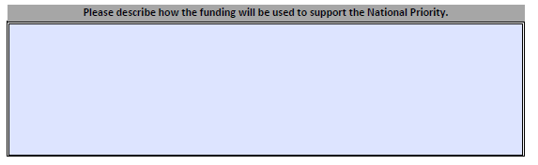

Mission Area:
Sections 1-5: Please mark the Mission Area(s) that the agency will support with funding received.
- Prevention: Prevent, avoid, or stop an imminent, threatened, or actual threat of terrorism

- Protection: Protect our citizens, residents, visitors, and assets against the greatest threats and hazards in a manner that allows our interests, aspirations, and way of life to thrive

- Mitigation: Reduce the loss of life and property by lessening the impact of future disasters.

- Response: Respond quickly to save lives, protect property and the environment, and meet basic human needs in the aftermath of an incident.

- Recovery: Recover through a focus on the timely restoration, strengthening and revitalization of infrastructure, housing, and a sustainable economy, as well as the health, social, cultural, historic, and environmental fabric of communities affected by an incident.

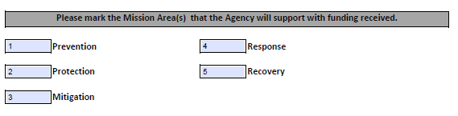
Please describe how the funding will be used to support the Mission Area (2).
Add a description of how the funds will be used to support the mission areas that were marked on the previous page. Use as much detail as possible to describe how the funds will be used.
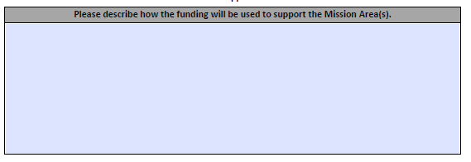

Core Capability Gap:
Please mark which Core Capability that the Agency will support with funding. For more information on the core capabilities, please see the following link to FEMA Core Capability Development Sheets.
https://www.fema.gov/sites/default/files/documents/fema_ccds-all-sheets.pdf

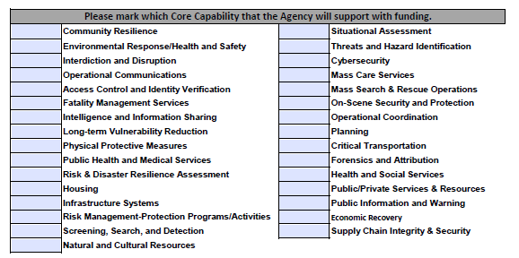

Please describe how the funding will be used to support the Core Capabilities marked above.
Add a description of how the funds will support the Core Capabilities. Use as much detail as possible to describe.

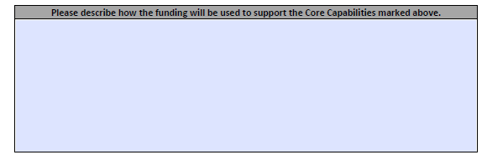

- Grant Budget:

- Personnel-Salary:
Submit information for proposed project staff that will be funded with federal funds under the grant agreement. All expenses must be in accordance with current state and federal guidelines. (Task Force, Operation Stonegarden, Training and Citizen Corp Grants Only)

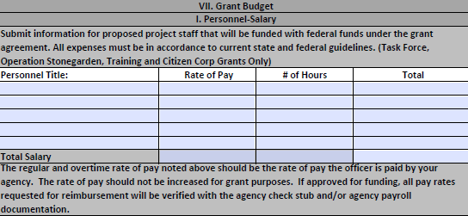

- Personnel-Fringe:
Submit information for proposed project staff that will be funded with federal funds under the grant agreement. All expenses must be in accordance with current state and federal guidelines. (Task Force, Operation Stonegarden, Training and Citizen Corp Grants Only)

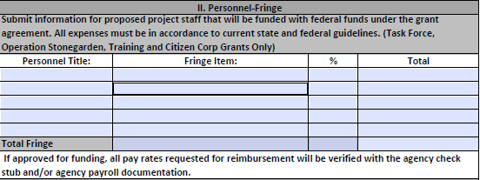

- Contractual Services:
Include a detailed assessment of contractual services within the program area in which applicant will be applying. Also, include a cost estimate for all contractual needs (rental, shipping costs, etc.). All expenses must be in accordance with current state and federal guidelines. (Task Force, Operation Stonegarden, Training and Citizen Corp Grants Only)

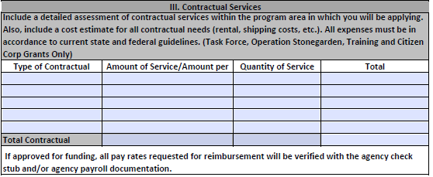

- Travel/Training:
Include a detailed assessment of travel/training needs within the program area in which applicant will be applying. Also, include a cost estimate for all travel needs (airfare, hotel, hotel taxes, per diem, mileage, parking, baggage, and gratuity). All expenses must be in accordance with current state and federal guidelines. (Task Force, Operation Stonegarden, Training and Citizen Corp Grants Only)

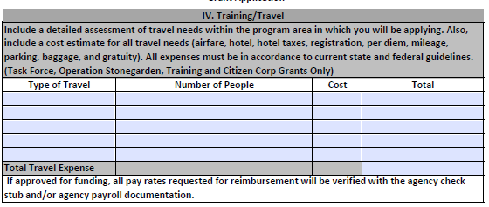

- Equipment:
All Equipment must be allowable, reasonable and must be essential to the project. All equipment must be on the FEMA Authorized Equipment List. Unallowable equipment: Guns, Ammunition, Body Cameras and Drones. (See Guidance for more Information)

AEL Numbers must be included in the application. Funding must be tied to threats, hazards, and capability gaps. Equipment must be essential to the program.

Fill out a section for each type of equipment requested. Add the total of all equipment costs at the end of the equipment section.

**Note** If additional spaces are needed for equipment, please add an additional page to the application.

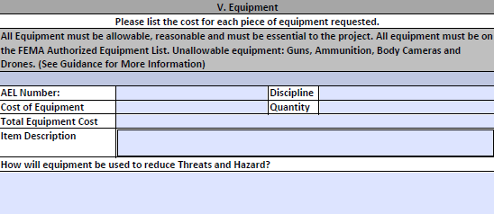

- Commodities/Supplies:
Include a detailed assessment of commodity/supply expenses within the program area in which applicant are applying. Also, include a cost estimate for all additional grant expenses (, gloves, traffic safety cones, flashlights, reflective safety vests, etc.). All expenses must be in accordance with current state and federal guidelines. Items are not identified as equipment.

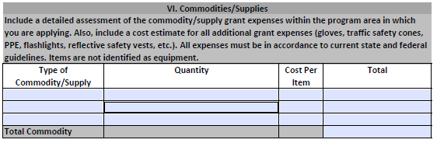

- Other:
Include a detailed assessment of any additional expenses within the program area, that may not be included in one of the above categories, in which applicant are applying. All expenses must be in accordance with current state and federal guidelines. Items are not identified as equipment.
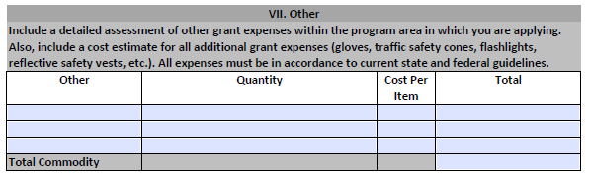
Additional Information:
If there is any additional information that the agency would like to provide on the budget for the application, please submit in the additional information box.
Total Amount of the Grant:
Please include a total of all budget sections for a total of the funding being requested.

VIII. Prior Experience:
Please fill out the below section to the best of applicant’s knowledge. Please mark applicants answer by a Yes or No Response. Complete all sections.
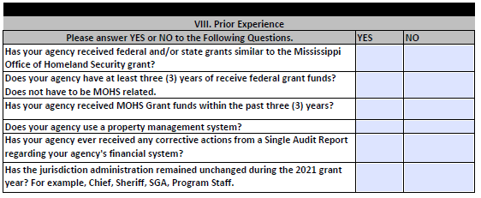
IX. NIMS Compliance Form

Please read the following statement, if agency agrees to NIMS Compliance, please have the Authorized Signatory Official Sign.

The National Incident Management System (NIMS)guides all levels of government, nongovernmental organizations (NGO), and the private sector to work together to prevent, protect against, mitigate, respond to, and recover from incidents. NIMS provides stakeholders across the whole community with the shared vocabulary, systems, and processes to successfully deliver the capabilities described in the National Preparedness System. As recipients and subrecipients of federal preparedness (non-disaster) grant awards, jurisdictions and organizations must achieve, or be actively working to achieve, all the NIMS Implementation Objectives. The objectives can be found on the NIMS webpage at: https://training.fema.gov/nims/
Under Executive Order #932, Mississippi established NIMS as the standard for incident management within the State. The U.S. Department of Homeland Security/Federal Emergency Management Agency guidance provides that accepting grant funding is conditioned upon NIMS compliance. This jurisdiction attests that we continue to strive toward NIMS compliance, as provided under federal and State NIMS guidance.
This jurisdiction understands receiving and/or using U.S. Department of Homeland Security grant funds remains conditional upon NIMS compliance. Non-compliance of NIMS can result in funds being withheld or reallocated from our jurisdiction because of ineffective NIMS support and participation.

- Submission Compliance
Please read the following statements, if applicants agency agrees with the submission compliance, please have the person completing the Application fill out the following:

